* 46% Domain 1: Kubernetes Fundamentals
* 22% Domain 2: Container Orchestration
* 16% Domain 3: Container Native Architecture
* 8% Domain 4: Cloud Native Observability
* 8% Domain 5: Cloud Native Application Delivery
* There are 60 questions on the exam
* The exam time is 90 minutes
* The passing score is 75%

**ExamPro** - <https://www.exampro.co/kcna>

**kubectl Cheat Sheet** - <https://kubernetes.io/docs/reference/kubectl/cheatsheet/>

<https://training.linuxfoundation.org/training/introduction-to-kubernetes/>

https://github.com/bradmccoydev/mentoring/blob/main/programs/kcna.md

**YouTube Videos:**

Plural Sight - <https://youtu.be/CO0e5lrPuC8>

<https://www.youtube.com/watch?v=iGkFHB1kFZ0>

<https://kubernetes.io/docs/home/>

# Cloud Native Computing Foundation (CNCF)

Cloud native computing uses an open source software stack to deploy applications as microservices, packaging each part into its own container, and dynamically orchestrating those containers to optimize resource utilization

Cloud native technologies empower organizations to build and run scalable applications in modern, dynamic environments such as public, private, and hybrid clouds. Containers, service meshes, microservices, immutable infrastructure, and declarative APIs exemplify this approach

Cloud native architecture can provide solutions for the increasing complexity of applications and the growing demand by users. The basic idea is to break down your application in smaller pieces which makes them more manageable. Instead of providing all functionality in a single application, you have multiple decoupled applications that communicate with each other in a network. If we stick to the example from before, you could have an app for your user interface, your checkout and everything else.

# Characteristics of Cloud Native Architecture

* High level of automation
* Self healing
* Scalable
* (Cost-) Efficient
* Easy to maintain
* Secure by default

# Autoscaling

# Dynamic adjustment of resources based on the current demand

Cloud environments rely on usage based on-demand pricing models provide very effective platforms for automatic scaling, with the ability to provision a large amount of resources within seconds or even scale to zero, if resources are temporarily not needed.

# Serverless

# cloud vendors have one or more commercial offerings of proprietary serverless runtimes and a subset of serverless, also known as [Function as a Service (FaaS)](https://www.youtube.com/watch?v=EOIja7yFScs). The cloud provider abstracts the underlying infrastructure (configure resources like a network, virtual machines, operating systems and load balancers to run a simple web application), so that developers can deploy software by uploading their code for example as .zip files or providing a container image.

# Open Standards

# Open Container Initiative provides two standards which define the way how to build and run containers. The [image-spec](https://github.com/opencontainers/image-spec) defines how to build and package container images. While the [runtime-spec](https://github.com/opencontainers/runtime-spec) specifies the configuration, execution environment and lifecycle of containers

* [OCI Spec](https://opencontainers.org/): image, runtime and distribution specification on how to run, build and distribute containers
* [Container Network Interface (CNI)](https://github.com/containernetworking/cni): A specification on how to implement networking for Containers.
* [Container Runtime Interface (CRI)](https://github.com/kubernetes/cri-api): A specification on how to implement container runtimes in container orchestration systems.
* [Container Storage Interface (CSI)](https://github.com/container-storage-interface/spec):A specification on how to implement storage in container orchestration systems.
* [Service Mesh Interface (SMI)](https://smi-spec.io/): Ap specification on how to implement Service Meshes in container orchestration systems with a focus on Kubernetes.

# Community and Governance

# The CNCF has a Technical Oversight Committee (TOC) that is responsible for defining and maintaining the technical vision, approving new projects, accepting feedback from the end-user committee, and defining common practices that should be implemented in CNCF projects.

# Container Orchestration

# Containers can be used to solve problems of managing the dependencies of an application and running much more efficiently than spinning up a lot of virtual machines.

# The chroot command could be used to isolate a process from the root filesystem and basically "hide" the files from the process and simulate a new root directory. The isolated environment is a so-called *chroot jail*, where the files can’t be accessed by the process, but are still present on the system.

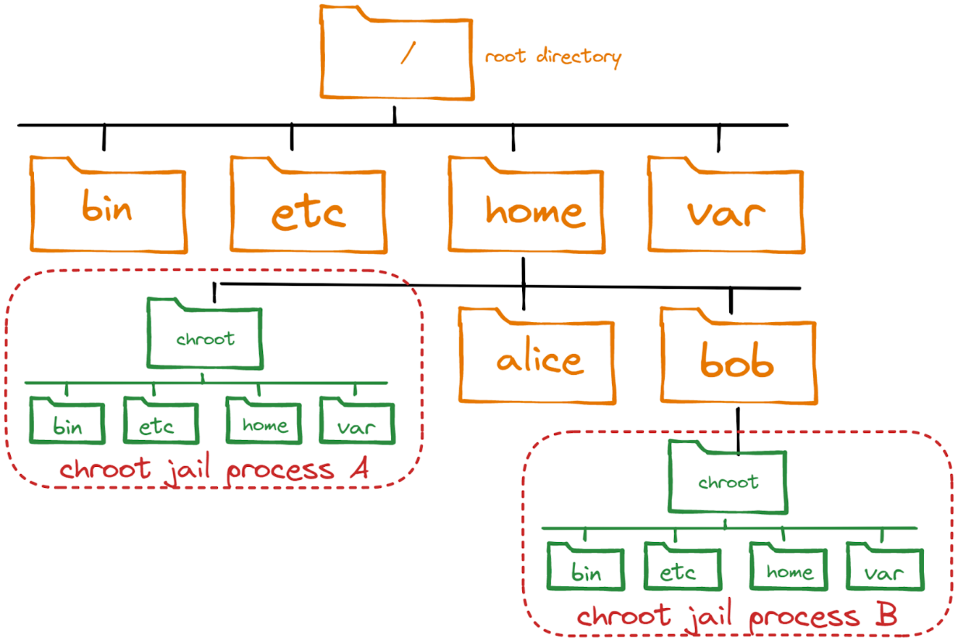

Container technologies embody this chroot concept. To isolate a process even more than chroot can do, current Linux kernels provide features like *namespaces* and cgroups.

Namespaces are used to isolate various resources, for example the network. A network namespace can be used to provide a complete abstraction of network interfaces and routing tables.

The Linux Kernel 5.6 currently provides 8 namespaces:

* pid - process ID provides a process with its own set of process IDs.
* net - network allows the processes to have their own network stack, including the IP address.
* mnt - mount abstracts the filesystem view and manages mount points.
* ipc - inter-process communication provides separation of named shared memory segments.
* user - provides process with their own set of user IDs and group IDs.
* uts - Unix time sharing allows processes to have their own hostname and domain name.
* cgroup - a newer namespace that allows a process to have its own set of cgroup root directories.
* time - the newest namespace can be used to virtualize the clock of the system.

cgroups are used to organize processes in hierarchical groups and assign them resources like memory and CPU

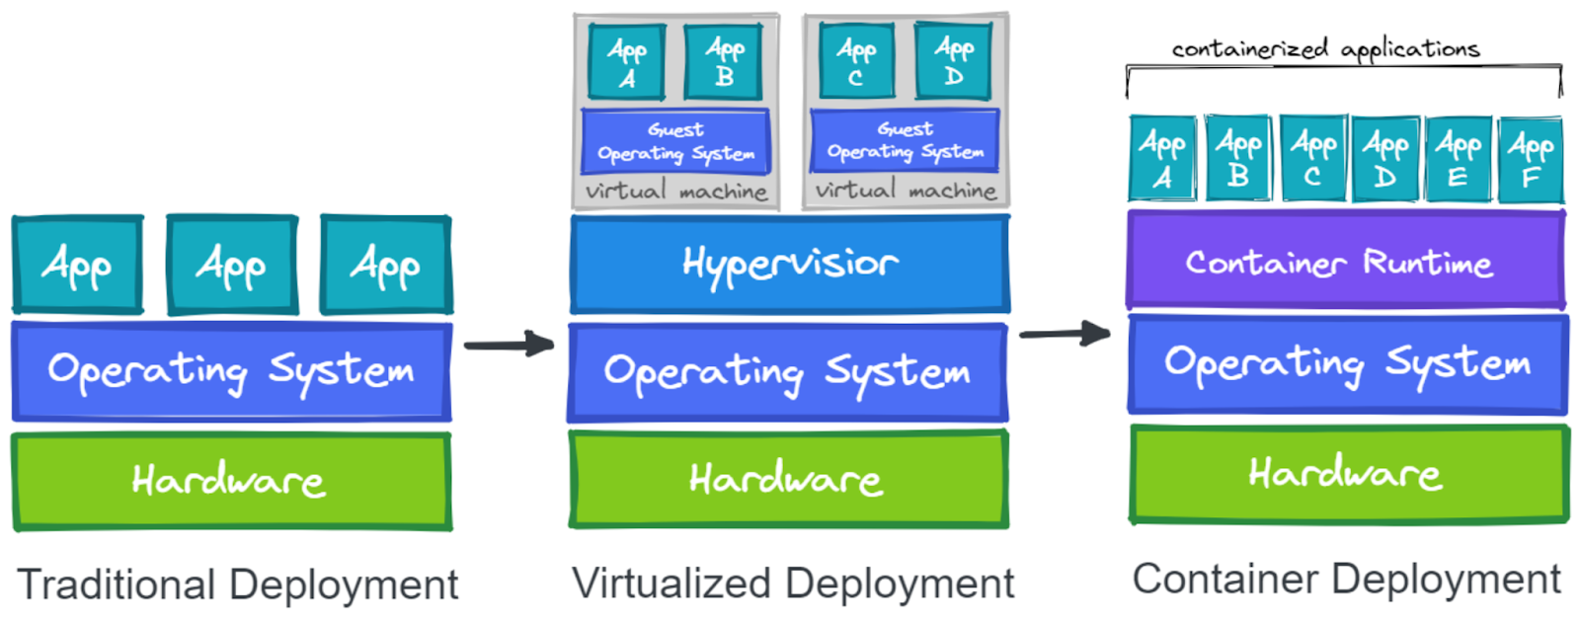

A Docker container image is a lightweight, standalone, executable package of software that includes everything needed to run an application: code, runtime, system tools, system libraries and settings

Container images are what makes containers portable and easy to reuse on a variety of systems. Images can be built by reading the instructions from a buildfile called Dockerfile.

**docker build -t my-python-image -f Dockerfile**

**docker push my-registry.com/my-python-image  
docker pull my-registry.com/my-python-image**

# Security

# When containers are started on a machine, they always share the same kernel, which then becomes a risk for the whole system, if containers are allowed to call kernel functions like for example killing other processes or modifying the host network by creating routing rules

One of the greatest security risks, not only in the container area, is the execution of processes with too many privileges, especially starting processes as root or administrator. The 4C's of Cloud Native security can give a rough idea what layers need to be protected if you’re using containers.

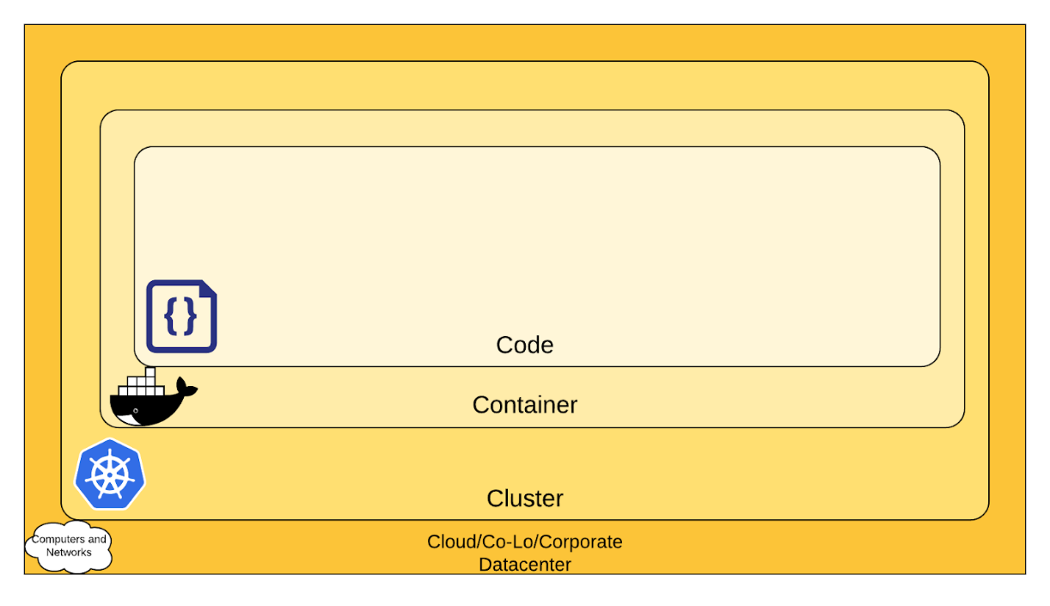

**Networking**

Most modern implementations of container networking are based on the [Container Network Interface (CNI)](https://github.com/containernetworking/cni). CNI is a standard that can be used to write or configure network plugins

Network namespaces allow each container to have its own unique IP address, therefore multiple applications can open the same network port; for example, you could have multiple containerized web servers that all open port 8080.

To make the application accessible from outside the host system, containers have the ability to map a port from the container to a port from the host system.

To allow communication between containers across hosts, we can use an overlay network which puts them in a virtual network that is spanned across the host systems.

**Service Discovery & DNS**

Containers are deployed on varieties of different hosts, different data centers or even geolocations. Containers or Services need DNS to communicate. Using IP addresses is nearly impossible

Instead of having a manually maintained list of servers (or in this case containers), all the information is put in a *Service Registry*. Finding other services in the network and requesting information about them is called *Service Discovery*

*DNS and Key value store are the approaches for Service Discovery.*

# Service Mesh

# A service mesh adds a proxy server to *every* container that you have in your architecture. The software you can use to manage network traffic is called a proxy. This is a server application that sits between a client and server and can modify or filter network traffic before it reaches the server.

# When a service mesh is used, applications don’t talk to each other directly, but the traffic is routed through the proxies instead. The most popular service meshes at the moment are [istio](https://istio.io/" \t "_blank) and [linkerd](https://linkerd.io/" \t "_blank).

# The proxies in a service mesh form the *data plane*. This is where networking rules are implemented and shape the traffic flow.

# So instead of writing code and installing libraries, you just write a config file where you tell the service mesh that service A and service B should always communicate encrypted. The config is then uploaded to the control plane and distributed to the data plane to enforce the new rule.

# 

**Storage**

The problem here is that this read-write layer is lost when the container is stopped or deleted. Just like the memory of your computer gets erased when you shut it down. To persist data, you need to write it to your disk**.**

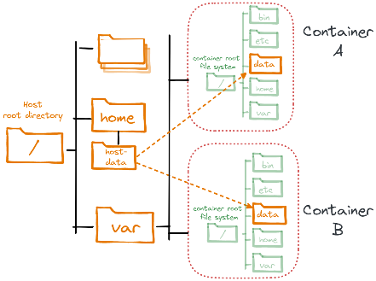

Container orchestration systems like Kubernetes can help to mitigate these problems, but always require a robust storage system that is attached to the host servers.

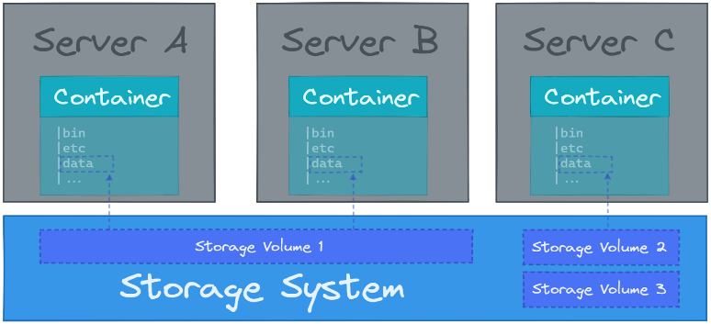

Storage is provisioned via a central storage system. Containers on Server A and Server B can share a volume to read and write data

**Kubernetes Architecture**

Kubernetes provides you with a framework to run distributed systems resiliently. It takes care of scaling and failover for your application, provides deployment patterns, and more. Kubernetes is often used as a cluster, meaning that it is spanned across multiple servers that work on different tasks and to distribute the load of a system

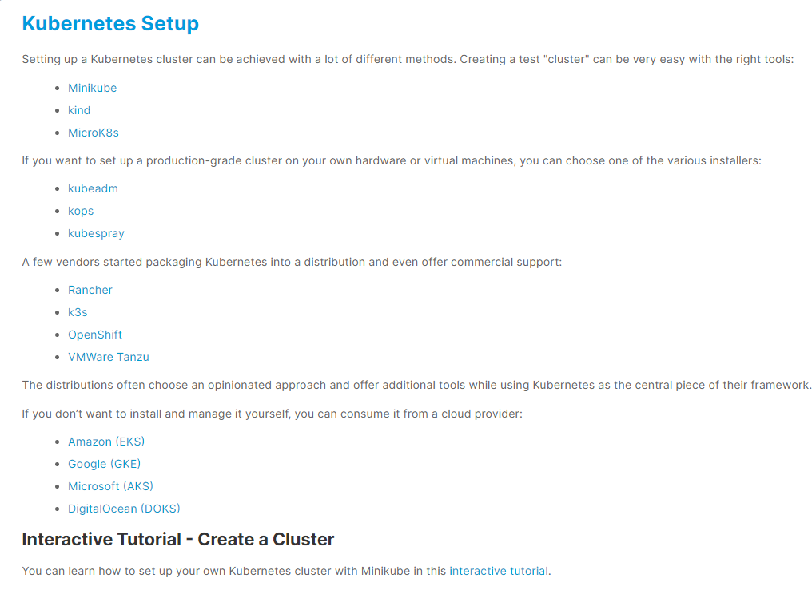

# Namespaces

In Kubernetes, *namespaces* provides a mechanism for isolating groups of resources within a single cluster

Kubernetes starts with four initial namespaces: **default, kube-node-lease, kube-public, kube-system**

Kubernetes provides you with

Service discovery and load balancing

Storage orchestration

Automated rollouts and rollbacks

Automatic bin packing

Self-healing

Secret and configuration management

Kubernetes clusters consist of two different server node types that make up a cluster

* **Control plane node(s)**  
  These are the brains of the operation. Control plane nodes contain various components which manage the cluster and control various tasks like deployment, scheduling and self-healing of containerized workloads.
* **Worker nodes**  
  The worker nodes are where applications run in your cluster. This is the only job of worker nodes and they don’t have any further logic implemented. Their behavior, like if they should start a container, is completely controlled by the control plane node.

Self-registering nodes - When the kubelet flag --register-node is true (the default), the kubelet will attempt to register itself with the API server

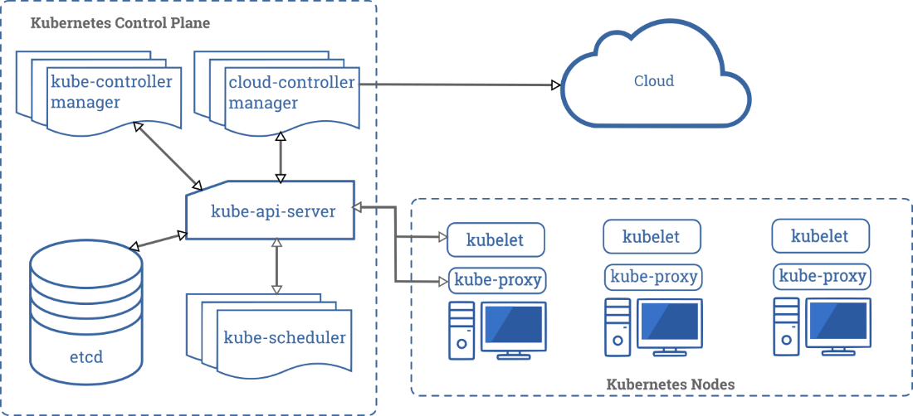

kubectl describe node – To view status of the node

**kube-apiserver**

This is the centerpiece of Kubernetes. All other components interact with the api-server and this is where users would access the cluster. It scales components horizontally.

**etcd**

A database which holds the state of the cluster. [etcd](https://etcd.io/" \t "_blank) is a standalone project and not an official part of Kubernetes.

**kube-scheduler**

When a new workload should be scheduled, the kube-scheduler chooses a worker node that could fit, based on different properties like CPU and memory.

**kube-controller-manager**

Contains different non-terminating control loops that manage the state of the cluster. For example, one of these control loops can make sure that a desired number of your application is available all the time.

**cloud-controller-manager (optional)**

Can be used to interact with the API of cloud providers, to create external resources like load balancers, storage or security groups.

***Components of worker nodes***

**container runtime**

The container runtime is responsible for running the containers on the worker node. For a long time, Docker was the most popular choice, but is now replaced in favor of other runtimes like [containerd](https://containerd.io/" \t "_blank).

**kubelet**

A small agent that runs on every worker node in the cluster. The kubelet talks to the api-server and the container runtime to handle the final stage of starting containers.

**kube-proxy**

A network proxy that handles inside and outside communication of your cluster. Instead of managing traffic flow on it’s own, the kube-proxy tries to rely on the networking capabilities of the underlying operating system if possible.

## **Addons**

Addons use Kubernetes resources ([DaemonSet](https://kubernetes.io/docs/concepts/workloads/controllers/daemonset" \t "_blank), [Deployment](https://kubernetes.io/docs/concepts/workloads/controllers/deployment/), etc) to implement cluster features. Because these are providing cluster-level features, namespaced resources for addons belong within the kube-system namespace. Few addons are DNS, Web UI, Container Resource Monitoring, Cluster Level logging rtc.

## **DNS**

It’s a service that is responsible for translating a service name to its IP address. CoreDNS is the default DNS server for Kubernetese.

While the other addons are not strictly required, all Kubernetes clusters should have [cluster DNS](https://kubernetes.io/docs/concepts/services-networking/dns-pod-service/), as many examples rely on it.

Cluster DNS is a DNS server, in addition to the other DNS server(s) in your environment, which serves DNS records for Kubernetes services.

Containers started by Kubernetes automatically include this DNS server in their DNS searches.

Configuration file in Kubernetese are called manifests. They are in the form of yml or json

**Kubernetes API**

The core of Kubernetes' [control plane](https://kubernetes.io/docs/reference/glossary/?all=true#term-control-plane) is the [API server](https://kubernetes.io/docs/concepts/overview/components/#kube-apiserver). The API server exposes an HTTP API that lets end users, different parts of your cluster, and external components communicate with one another

The Kubernetes API lets you query and manipulate the state of API objects in Kubernetes (for example: Pods, Namespaces, ConfigMaps, and Events).

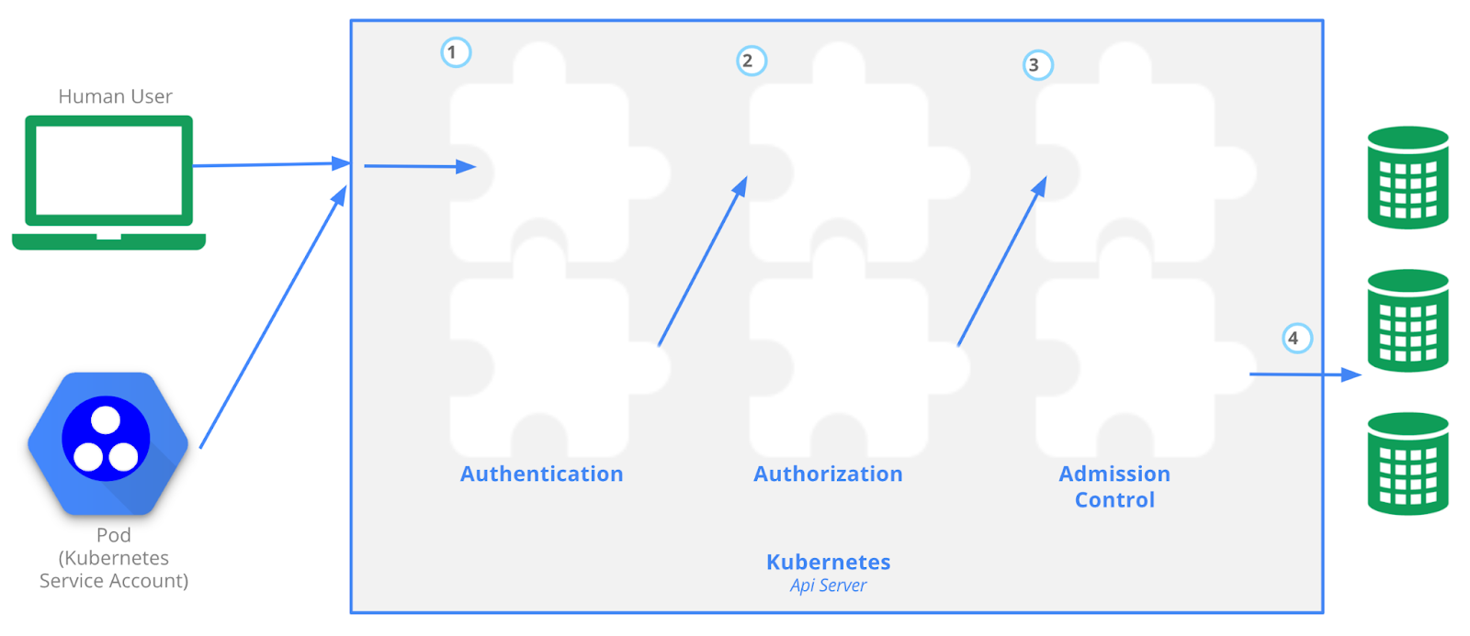

# Authentication The requester needs to present a means of identity to authenticate against the API. Commonly done with a digital signed certificate ([X.509](https://en.wikipedia.org/wiki/X.509)) or with an external identity management system. Kubernetes users are *always* externally managed. [Service Accounts](https://kubernetes.io/docs/reference/access-authn-authz/service-accounts-admin/) can be used to authenticate technical users.

# Authorization It is decided what the requester is allowed to do. In Kubernetes this can be done with [Role Based Access Control (RBAC)](https://kubernetes.io/docs/reference/access-authn-authz/rbac/).

# Admission Control In the last step, [admission controllers](https://kubernetes.io/docs/reference/access-authn-authz/admission-controllers/) can be used to modify or validate the request. For example, if a user tries to use a container image from an untrustworthy registry, an admission controller could block this request. Tools like the [Open Policy Agent](https://www.openpolicyagent.org/) can be used to manage admission control externally

# Running Containers on Kubernetes

The idea of containerd and CRI-O was very simple: provide a runtime that only contains the absolutely essentials to run containers. Nevertheless, they have additional features, like the ability to integrate with container runtime sandboxing tools. These tools try to solve the security problem that comes with sharing the kernel between multiple containers. The most common tools at the moment are:

* [gvisor](https://github.com/google/gvisor)  
  Made by Google, provides an application kernel that sits between the containerized process and the host kernel.
* [Kata Containers](https://katacontainers.io/)  
  A secure runtime that provides a lightweight virtual machine, but behaves like a container.

# Networking

Kubernetes distinguishes between four different networking problems that need to be solved:

1. **Container-to-Container communications**This can be solved by the Pod concept as we'll learn later. All the containers in a pod will have same IP address
2. **Pod-to-Pod communications**This can be solved with an overlay network. Veth is used to communicate b/w same pods. And for pods in different nodes used for ex VPC.
3. **Pod-to-Service communications**It is implemented by the kube-proxy and packet filter on the node.
4. **External-to-Service communications**It is implemented by the kube-proxy and packet filter on the node.

There are different ways to implement networking in Kubernetes, but also three important requirements:

* All pods can communicate with each other across nodes.
* All nodes can communicate with all pods.
* No Network Address Translation (NAT).

To implement networking, you can choose from a variety of network vendors like:

* [Project Calico](https://www.tigera.io/project-calico/)
* [Weave](https://www.weave.works/oss/net/)
* [Cilium](https://cilium.io/)

In Kubernetes, every Pod gets its own IP address, so there is no manual configuration involved. Moreover, most Kubernetes setups include a DNS server add-on called [core-dns](https://kubernetes.io/docs/tasks/administer-cluster/coredns/), which can provide service discovery and name resolution inside the cluster.

A deployment is responsible for keeping a set of pods running. A service is responsible for enabling network access to a set of pods

Endpoints is a way where service links to a pod

# Scheduling

In a Kubernetes cluster, the kube-scheduler is the component that makes the scheduling decision, but is not responsible for actually starting the workload. The scheduling process in Kubernetes always starts when a new Pod object is created. Remember that Kubernetes is using a declarative approach, where the Pod is only described first, then the scheduler selects a node where the Pod actually will get started by the kubelet and the container runtime

# Working with Kubernetes

Kubernetes has solutions for some inherent problems with containers and orchestration, be it configuration management, cross-node networking, routing of external traffic, load balancing or scaling of the pods.

# Workloads

A workload is an application running on Kubernetes. Whether your workload is a single component or several that work together on Kubernetes you run it inside a set of [*pods*](https://kubernetes.io/docs/concepts/workloads/pods)

# Kubernetes Objects

# Kubernetes objects are mostly abstract resources, they are used to describe how your workload should be handled.

# A Kubernetes object is a "record of intent"--once you create the object, the Kubernetes system will constantly work to ensure that object exists. By creating an object, you're effectively telling the Kubernetes system what you want your cluster's workload to look like; this is your cluster's *desired state*

# Almost every Kubernetes object includes two nested object fields that govern the object's configuration: the object spec and the object status. For objects that have a spec, you have to set this when you create the object, providing a description of the characteristics you want the resource to have: its *desired state*.

# Kubernetes objects can be distinguished between workload-oriented objects that are used for handling container workloads and infrastructure-oriented objects, that for example handle configuration, networking and security.

# Pods: Pod is a collection of containers that can run on a host. This resource is created by clients and scheduled onto hosts

# Common and mandatory objects in yaml are apiVersion, Kind, metadata (name) and spec

# 

You can list the available objects in your cluster with the following command:

$ kubectl api-resources

# $ kubectl explain pod

# $ kubectl explain pod.spec

# Interacting with Kubernetes

# To access the API, users can use the official command line interface client called kubectl. Kubectl uses a config file called kubeconfig. Kubeconfig can be used to manage multiple clusters users.

# Helm: Helm is a package manager for Kubernetes, which allows easier updates and interaction with objects. Helm packages Kubernetes objects in so-called Charts, which can be shared with others via a registry.

**Pod Concept**

The most important object in Kubernetes is a Pod. A pod describes a unit of one or more containers that share an isolation layer of namespaces and cgroups. It is the smallest deployable unit in Kubernetes, which also means that Kubernetes is not interacting with containers directly. The pod concept was introduced to allow running a combination of multiple processes that are interdependent. All containers inside a pod share an IP address and can share via the filesystem.

**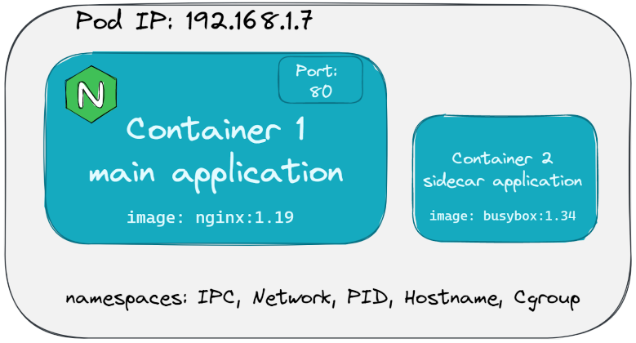**

**Multiple containers share namespaces to form a pod**

Here is an example of a simple Pod object with **two containers**:

**apiVersion: v1  
kind: Pod  
metadata:  
  name: nginx-with-sidecar  
spec:  
  containers:  
  - name: nginx  
    image: nginx:1.19  
    ports:  
    - containerPort: 80  
  - name: count  
    image: busybox:1.34  
    args: [/bin/sh, -c,  
            'i=0; while true; do echo "$i: $(date)"; i=$((i+1)); sleep 1; done']**

You could add as many containers to your main application as you want. But be careful since you lose the ability to scale them individually! Using a second container that supports your main application is called a sidecar container.

All containers defined are started at the same time with no ordering, but you also have the ability to use initContainers to start containers before your main application starts. In this example, the init container init-myservice tries to reach another service. Once it completes, the main container is started.

**apiVersion: v1  
kind: Pod  
metadata:  
  name: myapp-pod  
  labels:  
    app: myapp  
spec:  
  containers:  
  - name: myapp-container  
    image: busybox  
    command: ['sh', '-c', 'echo The app is running! && sleep 3600']  
  initContainers:  
  - name: init-myservice  
    image: busybox  
    command: ['sh', '-c', 'until nslookup myservice; do echo waiting for myservice; sleep 2; done;']**Make sure to explore the documentation about Pods, since there are many more settings to discover.

Probes are used to detect the state of the containers.

Some examples probes of important settings that can be set for every container in a Pod are:

resources: Set a resource request and a maximum limit for CPU and Memory.

livenessProbe: Configure a health check that periodically checks if your application is still alive. Containers can be restarted if the check fails.

securityContext: Set user & group settings, as well as kernel capabilities.

Readiness probe: When a container is ready to accept traffic

Startup probe: when application has started

You can use workload resources to create and manage multiple Pods for you. A controller for the resource handles replication and rollout and automatic healing in case of Pod failure.

PodTemplates are specifications for creating Pods, and are included in workload resources such as [Deployments](https://kubernetes.io/docs/concepts/workloads/controllers/deployment/), [Jobs](https://kubernetes.io/docs/concepts/workloads/controllers/job/), and [DaemonSets](https://kubernetes.io/docs/concepts/workloads/controllers/daemonset/).

when the Pod template for a workload resource is changed, the controller creates new Pods based on the updated template instead of updating or patching the existing Pods.

* Most of the metadata about a Pod is immutable. For example, you cannot change the namespace, name, uid, or creationTimestamp fields; the generation field is unique. It only accepts updates that increment the field's current value.
* Pod updates may not change fields than spec.containers[\*].image, spec.initContainers[\*].image, spec.activeDeadlineSeconds or spec.tolerations. For spec.tolerations, you can only add new entries.
* A Pod can specify a set of shared storage [volumes](https://kubernetes.io/docs/concepts/storage/volumes/). All containers in the Pod can access the shared volumes, allowing those containers to share data. Volumes also allow persistent data in a Pod to survive in case one of the containers within needs to be restarted

The name of a Pod must be a valid [DNS subdomain](https://kubernetes.io/docs/concepts/overview/working-with-objects/names#dns-subdomain-names) value. Every container in a Pod shares the network namespace, including the IP address and network ports.

*Static Pods* are managed directly by the kubelet daemon on a specific node, without the [API server](https://kubernetes.io/docs/concepts/overview/components/#kube-apiserver) observing them

A probe is a diagnostic performed periodically by the kubelet on a container. To perform a diagnostic, the kubelet can invoke different actions:

* ExecAction (performed with the help of the container runtime)
* TCPSocketAction (checked directly by the kubelet)
* HTTPGetAction (checked directly by the kubelet)

# Workload Objects

Working just with Pods would not be flexible enough in a container orchestration platform. For example, if a Pod is lost because a node failed, it is gone forever. To make sure that a defined number of Pod copies runs all the time, we can use controller objects that manage the pod for us.

**ReplicaSet**: A controller object that ensures a desired number of pods is running at any given time. ReplicaSets can be used to scale out applications and improve their availability. They do this by starting multiple copies of a pod definition.

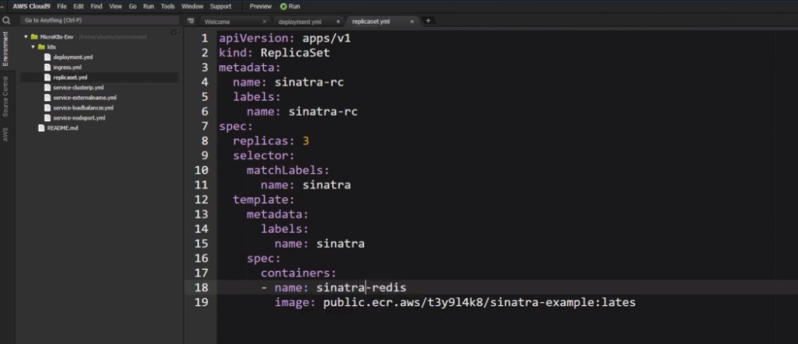

**Deployment**: The most feature-rich object in Kubernetes. A Deployment can be used to describe the complete application lifecycle, they do this by managing multiple ReplicaSets that get updated when the application is changed by providing a new container image, for example. Deployments are perfect to run stateless applications in Kubernetes. (A stateless app is an application program that does not save client data generated in one session for use in the next session with that client). A *Deployment* provides declarative updates for [Pods](https://kubernetes.io/docs/concepts/workloads/pods/) and [ReplicaSets](https://kubernetes.io/docs/concepts/workloads/controllers/replicaset/" \t "_blank).

Create the Deployment by running the following command:

kubectl apply -f <https://k8s.io/examples/controllers/nginx-deployment.yaml>

Run kubectl get deployments to check if the Deployment was created.

To update the nginx Pods to use the nginx:1.16.1 image instead of the nginx:1.14.2 image.

kubectl set image deployment/nginx-deployment nginx=nginx:1.16.1

Get details of your Deployment: kubectl describe deployments

**StatefulSet:** Considered a bad practice for a long time, StatefulSets can be used to run stateful applications like databases on Kubernetes. Stateful applications have special requirements that don't fit the ephemeral nature of pods and containers. In contrast to Deployments, StatefulSets try to retain IP addresses of pods and give them a stable name, persistent storage and more graceful handling of scaling and updates.

Unlike a Deployment, a StatefulSet maintains a sticky identity for each of their Pods.

Stateful set will always have unique and predictable names.A persistent volume will be attached. Will use headless services.

Ephemeral - loading for a very short time

**DaemonSet**: Ensures that a copy of a Pod runs on all (or some) nodes of your cluster. DaemonSets are perfect to run infrastructure-related workload, for example monitoring or logging tools.

**Job**: Creates one or more Pods that execute a task and terminate afterwards. Job objects are perfect to run one-shot scripts like database migrations or administrative tasks.

**CronJob**: CronJobs add a time-based configuration to jobs. This allows running Jobs periodically, for example doing a backup job every night at 4am.

S

# Networking Objects

# Since a lot of Pods would require a lot of manual network configuration, we can use *Service* and *Ingress objects* to define and abstract networking. Services can be used to expose a set of pods as a network service.

**ClusterIP**: The most common service type. A ClusterIP is a virtual IP inside Kubernetes that can be used as a single endpoint for a set of pods. This service type can be used as a round-robin load balancer.

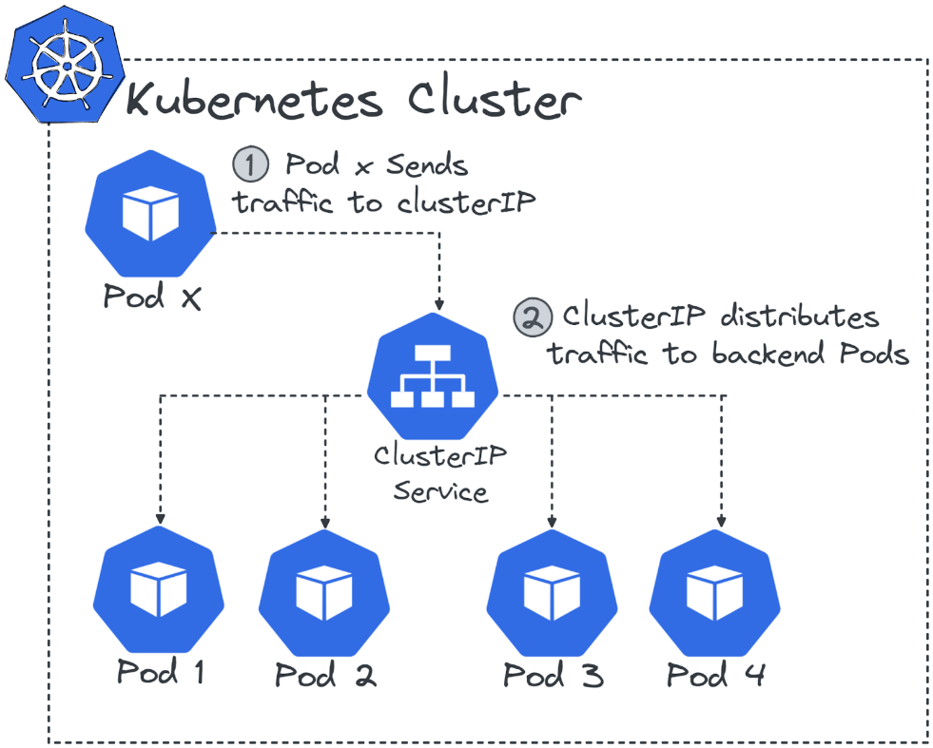

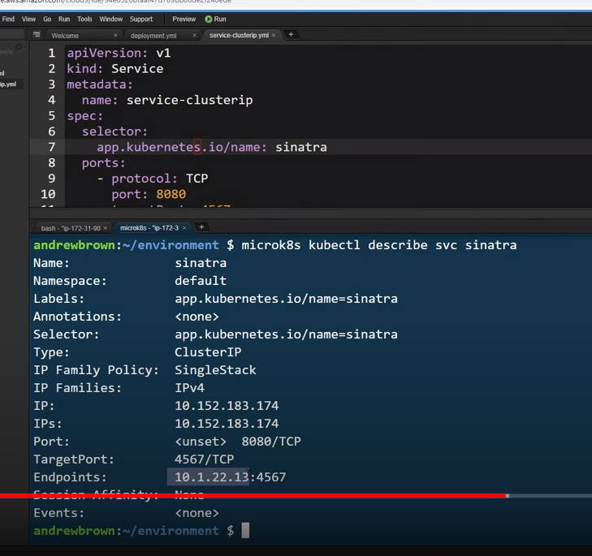

**NodePort:** The NodePort service type extends the ClusterIP by adding simple routing rules. It opens a port (default between 30000-32767) on every node in the cluster and maps it to the ClusterIP. This service type allows routing external traffic to the cluster.

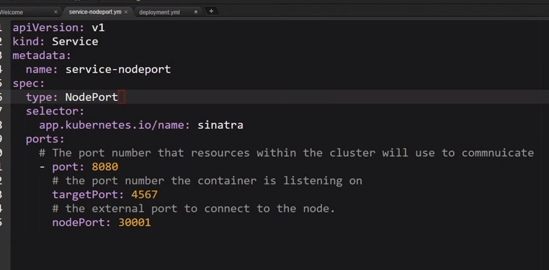

**LoadBalancer:** The LoadBalancer service type extends the NodePort by deploying an external LoadBalancer instance. This will only work if you’re in an environment that has an API to configure a LoadBalancer instance, like GCP, AWS, Azure or even OpenStack. (AWS has – Application, Network and gateway load balances)

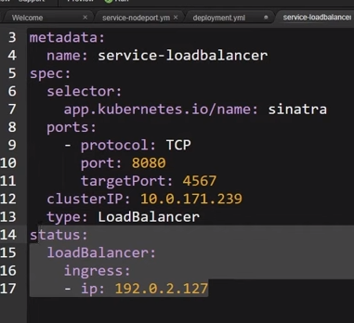s

**ExternalName:** A special service type that has no routing whatsoever. ExternalName is using the Kubernetes internal DNS server to create a DNS alias. You can use this to create a simple alias to resolve a rather complicated hostname like: my-cool-database-az1-uid123.cloud-provider-i-like.com. This is especially useful if you want to reach external resources from your Kubernetes cluster.

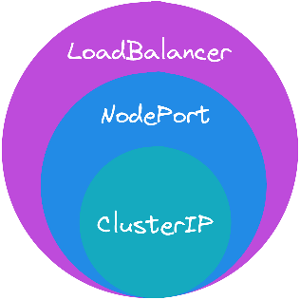

**Ingress**If you need even more flexibility to expose applications, you can use an *Ingress object*. Ingress provides a means to expose HTTP and HTTPS routes from outside of the cluster for a service within the cluster. It does this by configuring routing rules that a user can set and implement with an *ingress controller*.

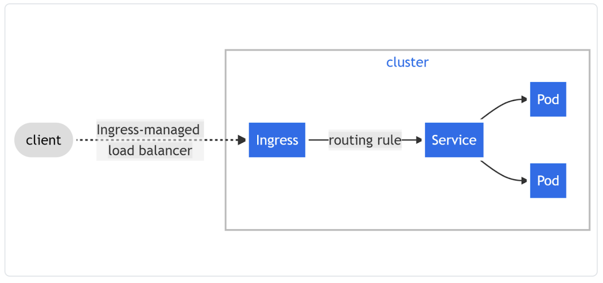

# Volume & Storage Objects

**apiVersion: v1  
kind: Pod  
metadata:  
  name: test-pd  
spec:  
  containers:  
  - image: k8s.gcr.io/test-webserver  
    name: test-container  
    volumeMounts:  
    - mountPath: /test-pd  
      name: test-volume  
  volumes:  
  - name: test-volume  
    hostPath:  
      # directory location on host  
      path: /data  
      # this field is optional  
      type: Directory**

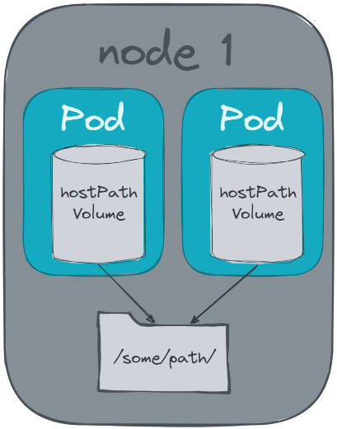

Volumes allow sharing data between multiple containers within the same Pod.

* **PersistentVolumes (PV)**  
  An abstract description for a slice of storage. The object configuration holds information like type of volume, volume size, access mode and unique identifiers and information how to mount it.
* **PersistentVolumeClaims (PVC)**  
  A request for storage by a user. If the cluster has multiple persistent volumes, the user can create a PVC which will reserve a persistent volume according to the user's needs.

# Configuration Objects

It is considered bad practice to incorporate the configuration directly into the container build. Any configuration change would require the entire image to be rebuilt and the entire container or pod to be redeployed. This problem gets only worse when multiple environments (development, staging, production) are used and images are being built for each and every environment. The twelve factor app explains this problem in more detail: [Dev/prod parity](https://12factor.net/dev-prod-parity).

In Kubernetes, this problem is solved by decoupling the configuration from the Pods with a ConfigMap. ConfigMaps can be used to store whole configuration files or variables as key-value pairs. There are two possible ways to use a ConfigMap:

* Mount a ConfigMap as a volume in Pod
* Map variables from a ConfigMap to environment variables of a Pod.

Here is an example of a ConfigMap that contains a nginx configuration:

**apiVersion: v1  
kind: ConfigMap  
metadata:  
  name: nginx-conf  
data:  
  nginx.conf: |  
    user nginx;  
    worker\_processes 3;  
    error\_log /var/log/nginx/error.log;  
...  
      server {  
          listen     80;  
          server\_name \_;  
          location / {  
              root   html;  
              index  index.html index.htm; } } }**

Once the ConfigMap is created you can use it in a Pod:

**apiVersion: v1  
kind: Pod  
metadata:  
  name: nginx  
spec:  
  containers:  
  - name: nginx  
    image: nginx:1.19  
    ports:  
    - containerPort: 80  
    volumeMounts:  
    - mountPath: /etc/nginx  
      name: nginx-conf  
  volumes:  
  - name: nginx-conf  
    configMap:  
      name: nginx-conf**

Right from the beginning Kubernetes also provided an object to store sensitive information like passwords, keys or other credentials. These objects are called *Secrets*. Secrets are very much related to ConfigMaps and basically their only difference is that secrets are base64 encoded.

There is an on-going debate about the risk of using Secrets, since their - in contrast to their name - not considered secure. In cloud-native environments purpose-built secret management tools have emerged that integrate very well with Kubernetes.

*Labels* are key/value pairs that are attached to objects, such as pods. Labels are intended to be used to specify identifying attributes of objects that are meaningful and relevant to users, but do not directly imply semantics to the core system. Cluster wide objects are Nodes, persistent volumes, storage class.

# Autoscaling Objects

# To scale the workload in a Kubernetes cluster, we can use three different Autoscaling mechanisms.

# [Horizontal Pod Autoscaler (HPA)](https://kubernetes.io/docs/tasks/run-application/horizontal-pod-autoscale/) is the most used autoscaler in Kubernetes. The HPA can watch Deployments or ReplicaSets and increase the number of Replicas if a certain threshold is reached. Imaging your Pod can use 500MiB of memory and you configured a threshold of 80%. If the usage is over 400MiB (80%), a second Pod will get scheduled. Now you have a capacity of 1000MiB. If 800MiB is used, a third Pod will get scheduled and so on.

**Cluster Autoscaler :** Of course, there is no point in starting more and more Replicas of Pods, if the Cluster capacity is fixed. The [Cluster Autoscaler](https://github.com/kubernetes/autoscaler/tree/master/cluster-autoscaler) can add new worker nodes to the cluster if the demand increases. The Cluster Autoscaler works great in tandem with the Horizontal Autoscaler.

**Vertical Pod Autoscaler:** The [Vertical Pod Autoscaler](https://github.com/kubernetes/autoscaler/tree/master/vertical-pod-autoscaler) is relatively new and allows Pods to increase the resource requests and limits dynamically. As we discussed earlier, vertical scaling is limited by the node capacity.

autoscaling in Kubernetes is NOT available out of the box and requires installing an add-on called [metrics-server](https://github.com/kubernetes-sigs/metrics-server).

It is possible though to replace the metrics-server with [Prometheus Adapter for Kubernetes Metrics APIs](https://github.com/kubernetes-sigs/prometheus-adapter). The prometheus-adapter allows you to use custom metrics in Kubernetes and scale up or down based on things like requests or number of users on your system.

[KEDA](https://keda.sh/) can be used to scale the Kubernetes workload based on events triggered by external systems. KEDA stands for Kubernetes-based Event Driven Autoscaler and was started in 2019 as a partnership between Microsoft and Red Hat. Similar to the HPA, KEDA can scale deployments, ReplicaSets, pods, etc., but also other objects such as Kubernetes jobs. With a large selection of out-of-the-box scalers, KEDA can scale to special triggers such as a database query or even the number of pods in a Kubernetes cluster.

**GitOps**

GitOps used to manage infrastructure changes.

There are two different approaches how a CI/CD pipeline can implement the changes you want to make:

* **Push-based**  
  The pipeline is started and runs tools that make the changes in the platform. Changes can be triggered by a commit or merge request.
* **Pull-based**  
  An agent watches the git repository for changes and compares the definition in the repository with the actual running state. If changes are detected, the agent applies the changes to the infrastructure.
* 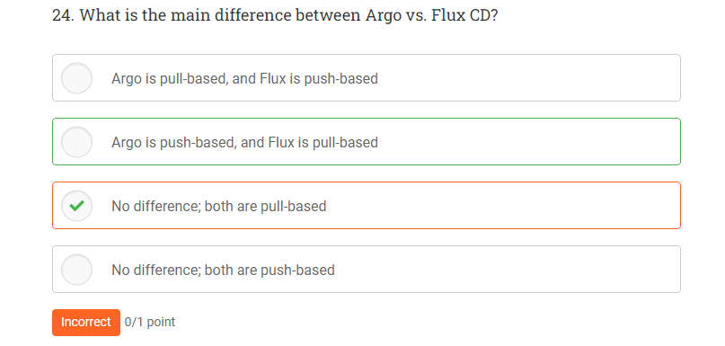

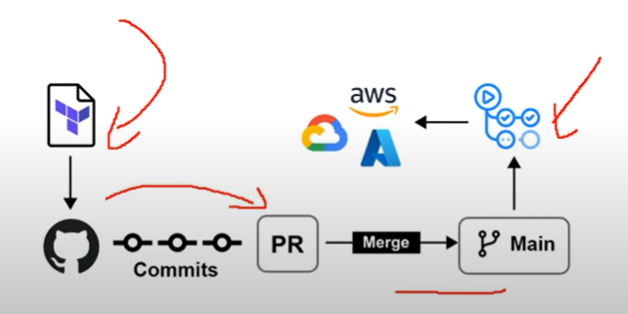

**Observability**

Observability should give answers to questions like:

* Is the system stable or does it change its state when manipulated?
* Is the system sensitive to change, e.g. if some services have high latency?
* Do certain metrics in the system exceed their limits?
* Why does a request to the system fail?
* Are there any bottlenecks in the system?

**Telemetry**

In container systems, each and every application should have tools built in that generate information data, which is then collected and transferred in a centralized system. The data can be divided into three categories, logs, metrics and tracks.

**Logging**

Command line tools like **docker**, **kubectl** or **podman** provide a command to show the logs of containerized processes if you let them log directly to the console or to **/dev/stdout** and **/dev/stderr**. Ex. **docker logs nginx, kubectl logs nginx.**

* **Node-level logging**  
  The most efficient way to collect logs. An administrator configures a log shipping tool that collects logs and ships them to a central store.
* **Logging via sidecar container**  
  The application has a sidecar container that collects the logs and ships them to a central store.
* **Application-level logging**  
  The application pushes the logs directly to the central store. While this seems very convenient at first, it requires configuring the logging adapter in every application that runs in a cluster.

There are several tools to choose from to ship and store the logs. The first two methods can be done by tools like [fluentd](https://www.fluentd.org/" \t "_blank) or [filebeat](https://www.elastic.co/beats/filebeat" \t "_blank). Popular choices to store logs are [OpenSearch](https://opensearch.org/) or [Grafana Loki](https://grafana.com/oss/loki/).

**Prometheus**

[Prometheus](https://prometheus.io/) is an open source monitoring system. To query data that is stored in the time series database, Prometheus provides a querying language called [PromQL (Prometheus Query Language)](https://prometheus.io/docs/prometheus/latest/querying/basics/" \t "_blank). Graphana is data visualization tool used with Prometheus.

**Tracing**

To understand how a request is processed in a microservice architecture, traces can be of good use. A trace describes the tracking of a request while it passes through the services. A trace consists of multiple units of work which represent the different events that occur while the request is passing the system. Each application can contribute a span to the trace, which can include information like start and finish time, name, tags or a log message. These traces can be stored and analyzed in a tracing system like [Jaeger](https://www.jaegertracing.io/).

**Cost Management**

Identify wasted and unused resources

Right-Sizing

Reserved Instances

Reserved Instances

**Authentication of kubectl with cluster**   
By default kubectl will first determine if it is running within a pod, and thus in a cluster. It starts by checking for the KUBERNETES\_SERVICE\_HOST and KUBERNETES\_SERVICE\_PORT environment variables and the existence of a service account token file at /var/run/secrets/kubernetes.io/serviceaccount/token. If all three are found in-cluster authentication is assumed.

**Kubectl Common Operations:**

Kubectl has lot of operations likeget, expose, config, auth, attach, certificate, cp, diff etc.

Kubectl supports resources like nodes, events, pods, services, secrets, deployments etc.

We can format the output using kubectl using option -o

Kubectl create -f filename --- create a resource form file or stdin

There are many sub actions for create like clusterrole, clusterrolebinding, configmap, cronjob, ingress, deployment, job, namespace, priorityclass, quota, role, secrets, service, token etc. Examples of important operations are as below

kubectl create deployment NAME --image=image -- [COMMAND] [args...]

kubectl create clusterip NAME [--tcp=<port>:<targetPort>] [--dry-run=server|client|none]

kubectl get -o json pod web-pod-13je7 --- Display one or many resources. Prints a table of the most important information about the specified resources. You can filter the list using a label selector and the --selector flag

Kubectl run nginx –image=nginx --- Create and run a particular image in a pod.

kubectl expose rc nginx --port=80 --target-port=8000 - Expose a resource as a new Kubernetes service. Looks up a deployment, service, replica set, replication controller or pod by name and uses the selector for that resource as the selector for a new service on the specified port

kubectl delete -f ./pod.json - Delete resources by file names, stdin, resources and names, or by resources and label selector.

kubectl apply -f ./pod.json - Apply a configuration to a resource by file name or stdin

Kubectl annotate - Update the annotations (descriptions or explanations) on one or more resources.

kubectl autoscale deployment foo --min=2 --max=10 --- Creates an autoscaler that automatically chooses and sets the number of pods that run in a Kubernetes cluster.

kubectl debug mypod -it --image=busybox - Debug cluster resources using interactive debugging containers.

kubectl diff -f pod.json --- Diff configurations specified by file name or stdin between the current online configuration, and the configuration as it would be if applied.

kubectl edit svc/registry -- Edit a resource from the default editor.

kubectl label --overwrite pods foo status=unhealthy --- *A label key and value must begin with a letter or number, and may contain letters, numbers, hyphens, dots, and underscores, up to 63 characters each.*

*kubectl patch node k8s-node-1 -p '{"spec":{"unschedulable":true}}' -* Update fields of a resource using strategic merge patch, a JSON merge patch, or a JSON patch.JSON and YAML formats are accepted.

*kubectl replace -f ./pod.json* -- Replace a resource by file name or stdin.JSON and YAML formats are accepted.

Kubectl rollout history/pause/restart/status/resume/undo Manage the rollout of one or many resources.Valid resource types include:deployments*,* daemonsets, statefulsets

kubectl scale **--replicas**=3 rs/foo ---- Set a new size for a deployment, replica set, replication controller, or stateful set.

kubectl set env/image/resources/selector/serviceaccount/subject ---- Configure application resources.These commands help you make changes to existing application resources.

Kubectl attach --- Attach to a process that is already running inside an existing container.

Kubectl auth can-i(Check whether an action is allowed)/reconcile(Reconciles rules for RBAC role, role binding, cluster role, and cluster role binding objects) ---- Copy files and directories to and from containers.

Kubectl cp src dest -- Copy files and directories to and from containers.

Kubectl describe - Show details of a specific resource or group of resources

Kubectl exec – execute a command in container

Kubectl logs --- Print the logs for a container in a pod or specified resource. If the pod has only one container, the container name is optional.

Kubectl port-forward --- Forward one or more local ports to a pod

Kubectl proxy --- Creates a proxy server or application-level gateway between localhost and the Kubernetes API server

Kubectl top node/pod -- The top command allows you to see the resource consumption for nodes or pods

Kubectl api-versions ---- Print the supported API versions on the server, in the form of "group/version".

Kubectl certificate approve/deny ---- Modify certificate resources.

Kubectl cluste-info ---- Display addresses of the control plane and services with label kubernetes.io/cluster-service=true.

Kubectl cordon --- Mark node as unschedulable.

Kubectl drain --- Drain node in preparation for maintenance.The given node will be marked unschedulable to prevent new pods from arriving

Kubectl config set/set-cluster/get-user/view/delete-user/delete-cluster/current-context etc ---- Modify kubeconfig files using subcommands like "kubectl config set current-context my-context"

Kubectl explain - List the fields for supported resources.This command describes the fields associated with each supported API resource. Fields are identified via a simple JSONPath identifier:  
<type>.<fieldName>[.<fieldName>]

kubectl api-resources **----** Print the supported API resources on the server.

RollingUpdate Deployments support running multiple versions of an application at the same time.

Kubernetes objects are RESTful objects

This volume type can be used to share contents within containers in a pod, but will not persist beyond the life of a pod is called EmptyDir

An abstraction in kubernetes which defines a logical set of pods and a policy to access them is called Service

Kube-apiserver on kubernetes master is designed to scale Horizontally

Cronjobs in kubernetes run in UTC only

PersistentVolumes and Nodes does not associate with any namespace.

Which 2 steps does the scheduler perform to select a node for a pod – Scoring and Filtering

Which authentication method allows JWTs to authenticate? --- OpenId connect

In distributed system tracing, is the term used to refer to a request as it passes through a single com-ponent of the distributed system? ---- Span

Cgroups allows limitations like Prioritization, Resource Limiting, Accounting, and Control

**Which of the following provides cloud-native storage orchestration?**

* **Cloud Provider Specific storage (EBS, EFS, Cloud Storage)** correct
* Cloud Storage
* Storage IO

**Which is not a service type in Kubernetes?**

* ClusterIP
* NodePort
* **Ingress** correct
* LoadBalancer
* ExternalName

|  |  |
| --- | --- |
| Containerization | Docker, gvisor, kata containers |
| CI/CD | Agro (Kunernetese-native tool) |
| Packaging | Helm |
| Monitoring | Prometheus |
| Logging | Fluentd, Graphana loki, opensearch, filebeat |
| Tracing | Jaeger |
| Service Discovery | CoreDNS |
| Service mesh | Envoy, Linkered, Istio |
| Database and storage | Vitess, Rook, TiKV |
| Streaming and messaging | gRPC, NATS, Cloudevents |
| Container Registry | Cri-o, containered-d, Harbor |
| Container Runtime reference Implementation (by OCI) | runC |
| Podman | Similar |
| Public Imahe registry | Docker hub, Quay |
| Networking for Kubernetese | Cilium, Weave, project calico |
| GitOps pull based approach | Flux and ArgoCD |
| Data Visualization | Graphana |

SRE uses 3 main metrics

**Service Level Objectives (SLO)**

**Service Level Indicators (SLI)**

**Service Level Agreements (SLA)**

Kops – Kubernetese operations

Namespace-based scoping is applicable only for namespaced objects *(e.g. Deployments, Services, etc)* and not for cluster-wide objects *(e.g. StorageClass, Nodes, PersistentVolumes, etc)*

Management of multiple resources can be simplified by grouping them together in the same file (separated by --- in YAML).

assume there is a directory project/k8s/development that holds all of the [manifests](https://kubernetes.io/docs/reference/glossary/?all=true#term-manifest) needed for the development environment, organized by resource type:

project/k8s/development

├── configmap

│   └── my-configmap.yaml

├── deployment

│   └── my-deployment.yaml

└── pvc

└── my-pvc.yaml

performing a bulk operation on project/k8s/development can be done by specifying the --recursive or -R flag with the --filename,-f by giving all the file names

**Canary Deployment**

multiple labels are needed is to distinguish deployments of different releases or configurations of the same component. It is common practice to deploy a *canary* of a new application release (specified via image tag in the pod template) side by side with the previous release so that the new release can receive live production traffic before fully rolling it out.

you can use [kubectl apply](https://kubernetes.io/docs/reference/generated/kubectl/kubectl-commands/" \l "apply) to push your configuration changes to the cluster.

**Blue Green deployment**

Blue green deployment is an application release model that gradually transfers user traffic from a previous version of an app or microservice to a nearly identical new release—both of which are running in production

**Zero Downtime deployments**

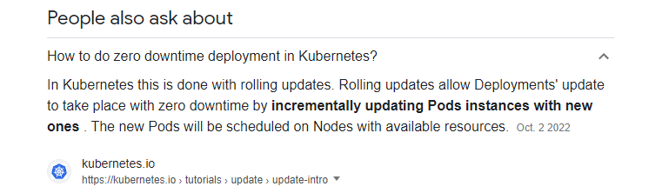

**Custom Resources**

Kubernetes API has a few built-in objects that it understands like pods, namespaces, ConfigMaps, services or nodes are all API objects. *Custom resources* are extensions of the Kubernetes API. We can create one or use existing many Kubernetes tools will install their own CRDs, so even if you don’t create any yourself, you’ll probably still end up having some on your cluster.One example is [cert-manager](https://cert-manager.io/), a very popular Kubernetes tool for managing certificates. It installs a few CRDs on your cluster in order to do its job. If you execute kubectl get clusterissuers you get all the certs

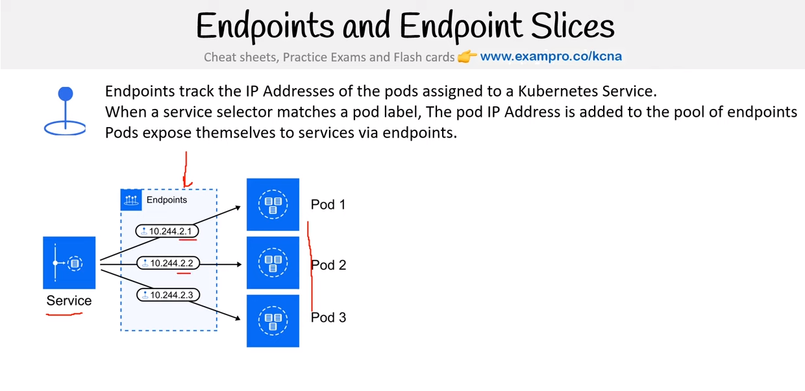

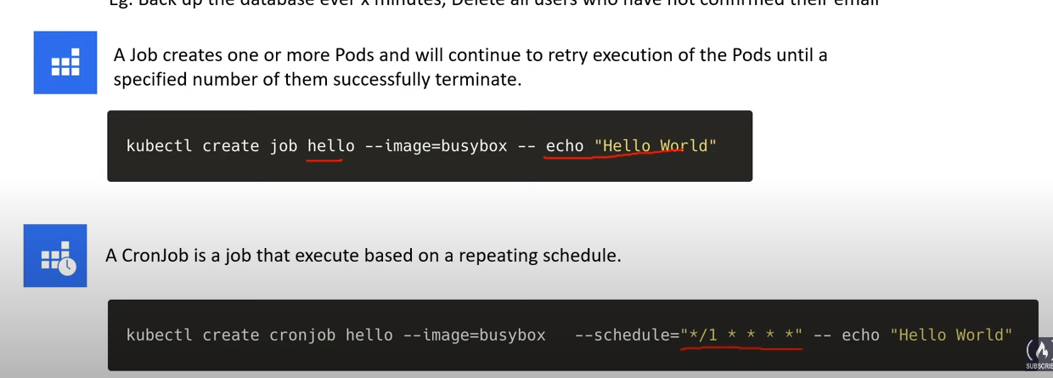

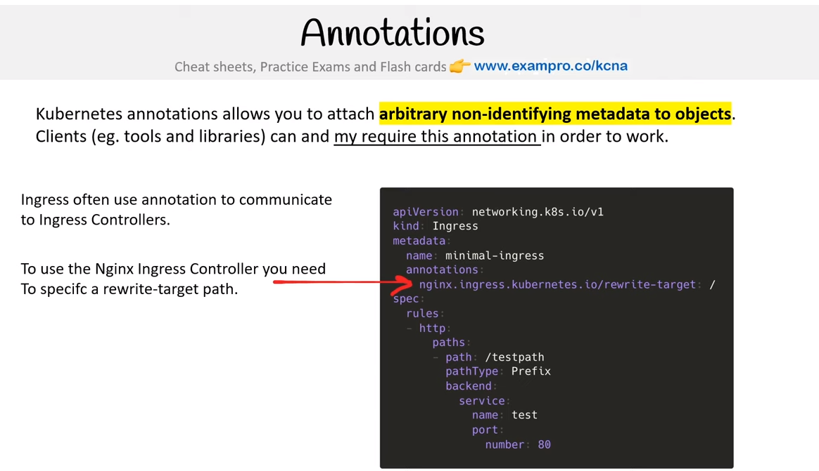

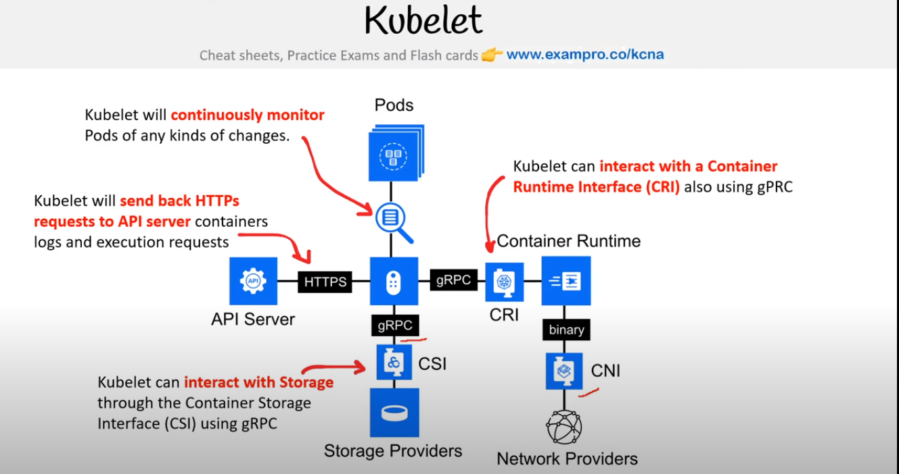

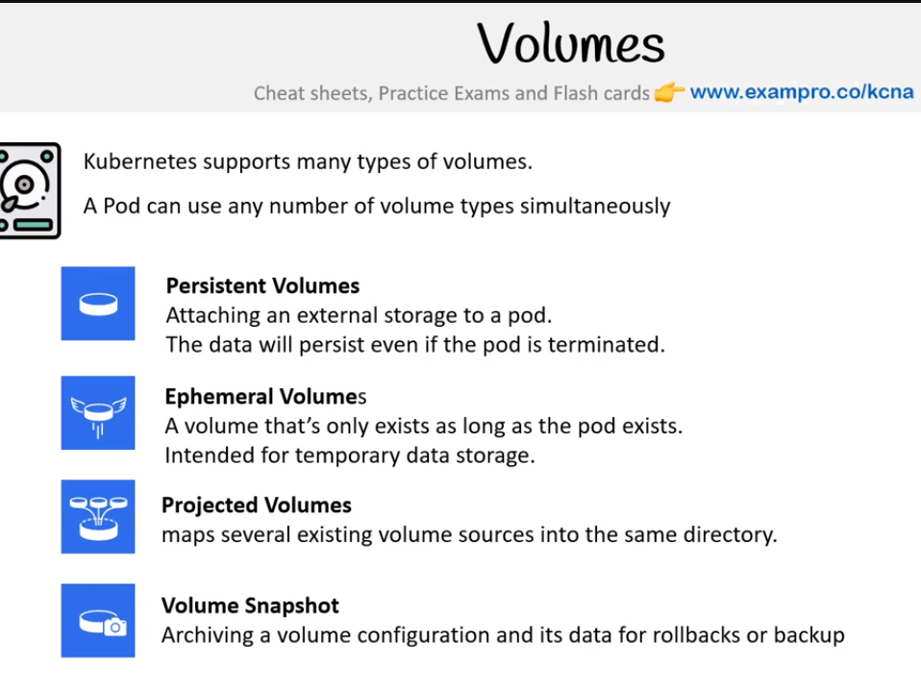

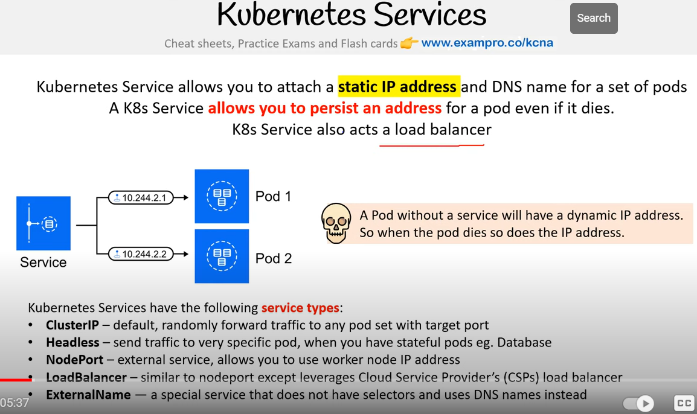

kubectl get services *# List all services in the namespace*

kubectl get pods --all-namespaces *# List all pods in all namespaces*

kubectl get pods -o wide *# List all pods in the current namespace, with more details*

kubectl get deployment my-dep *# List a particular deployment*

kubectl get pods *# List all pods in the namespace*

kubectl get pod my-pod -o yaml *# Get a pod's YAML*

# 

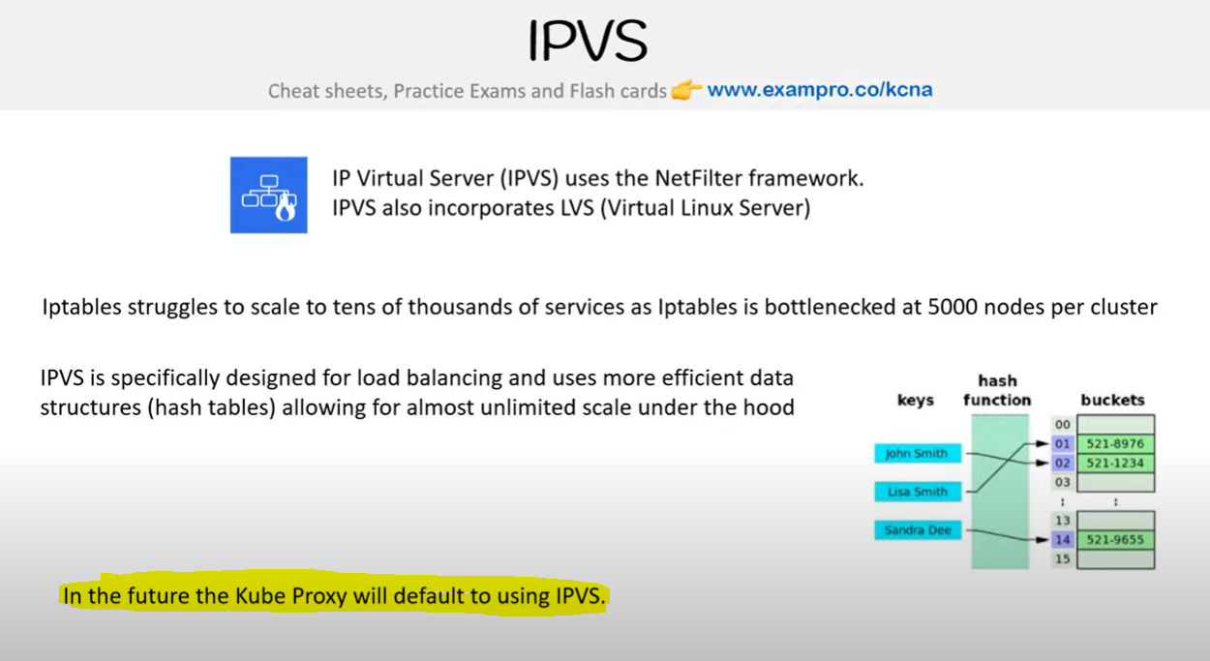

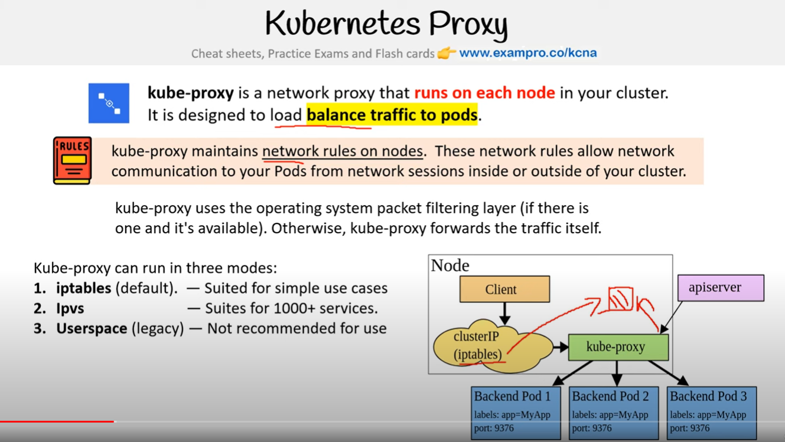

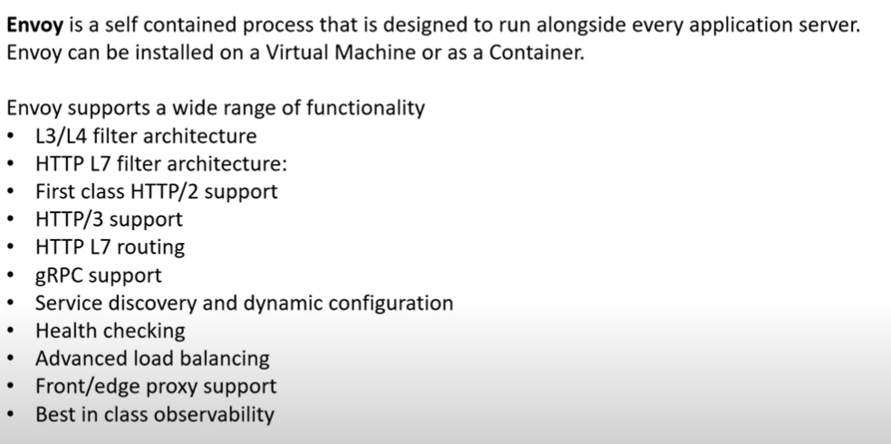

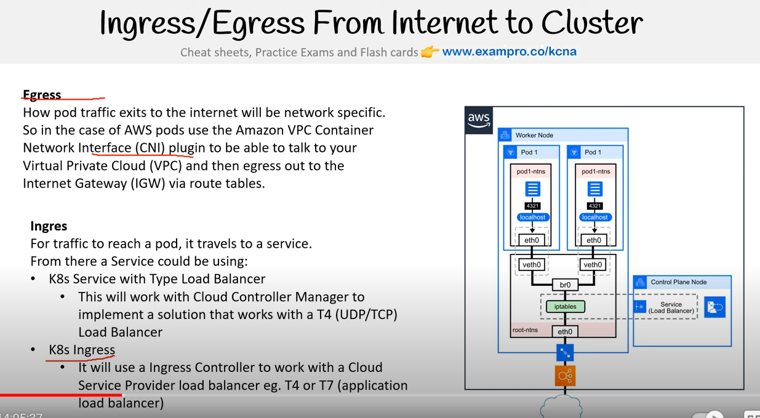

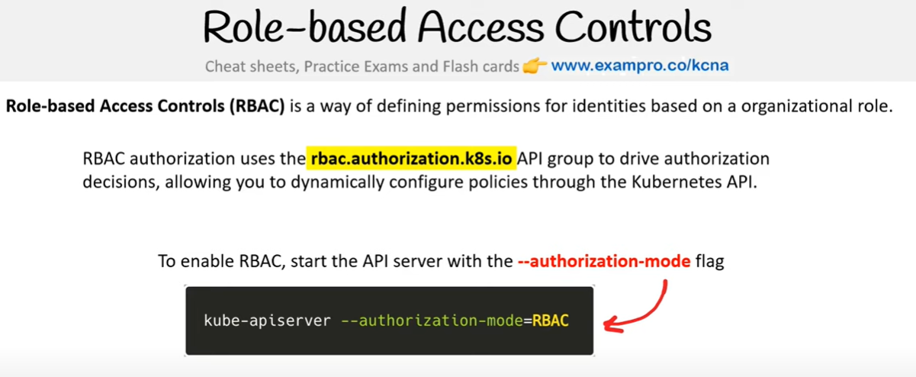

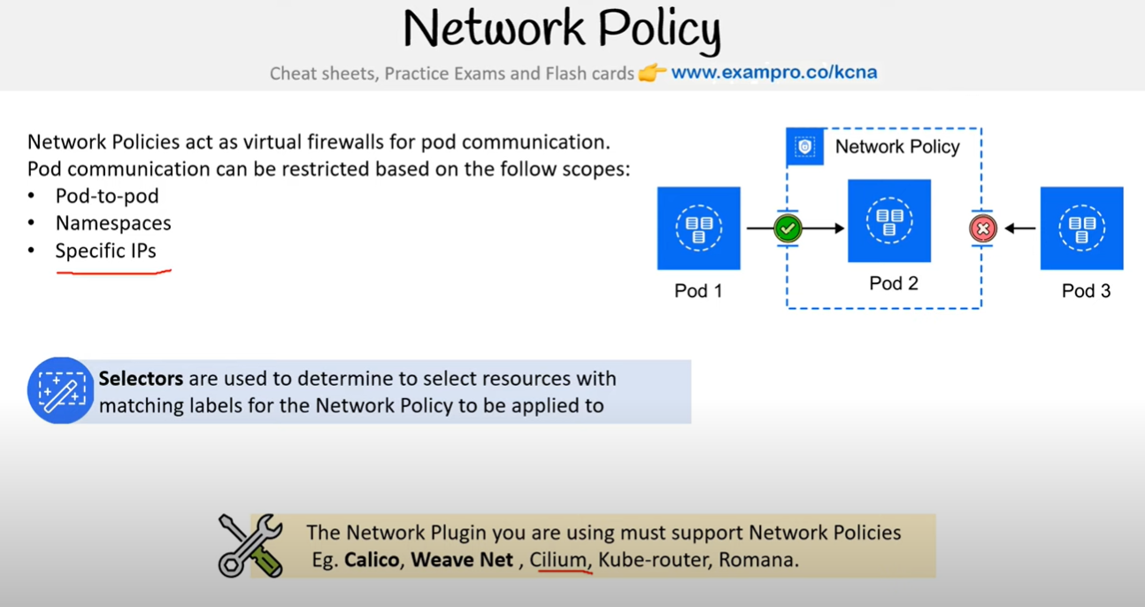

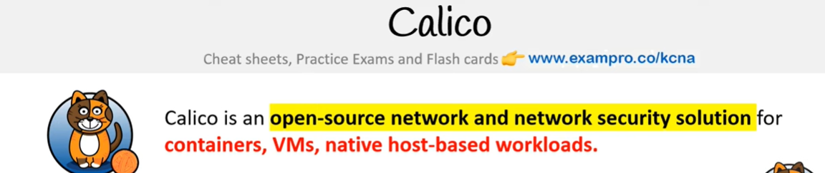

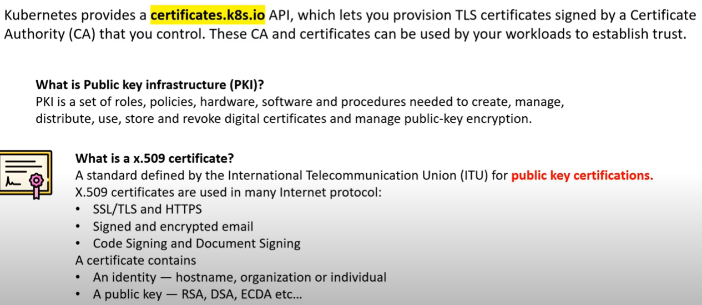

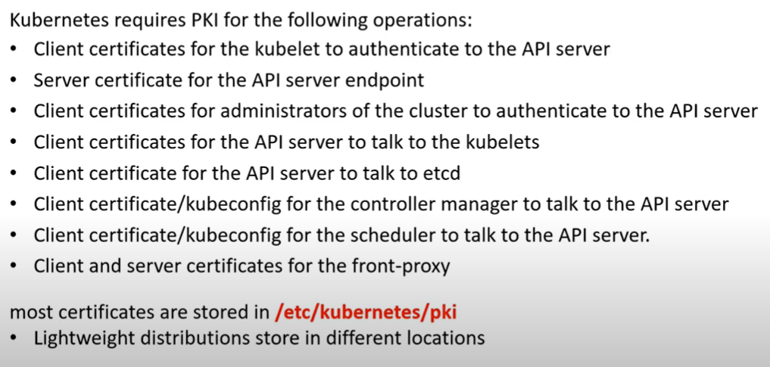

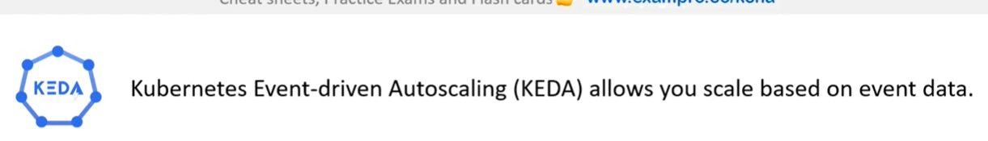

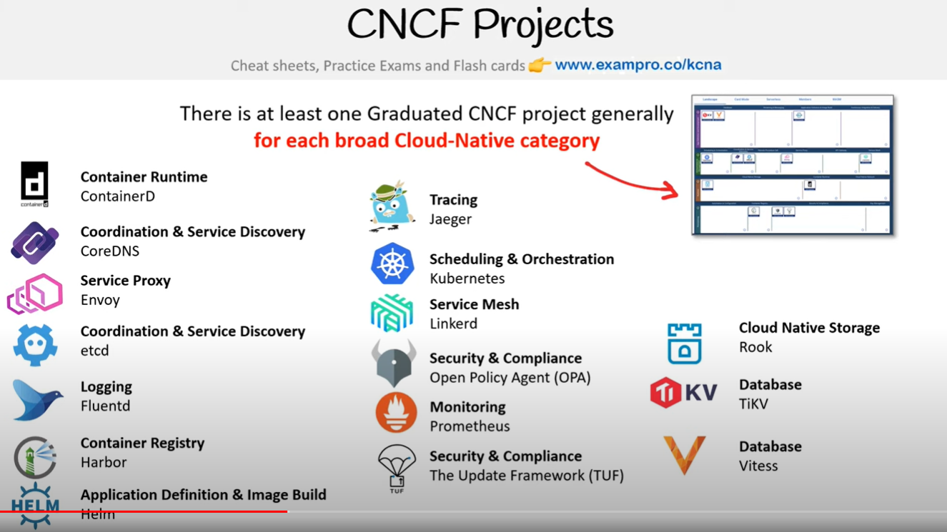

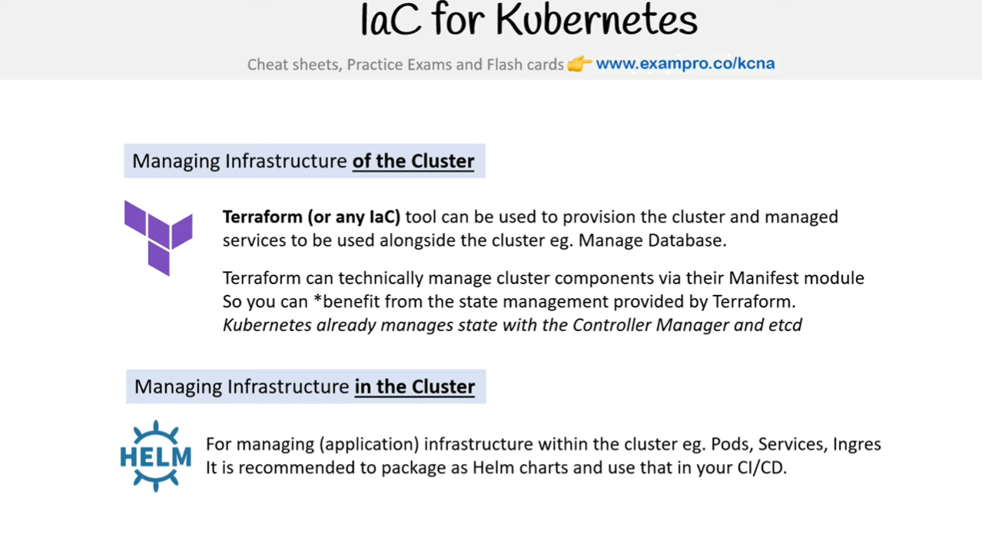

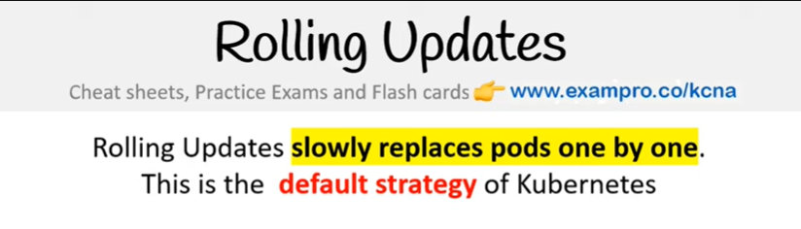

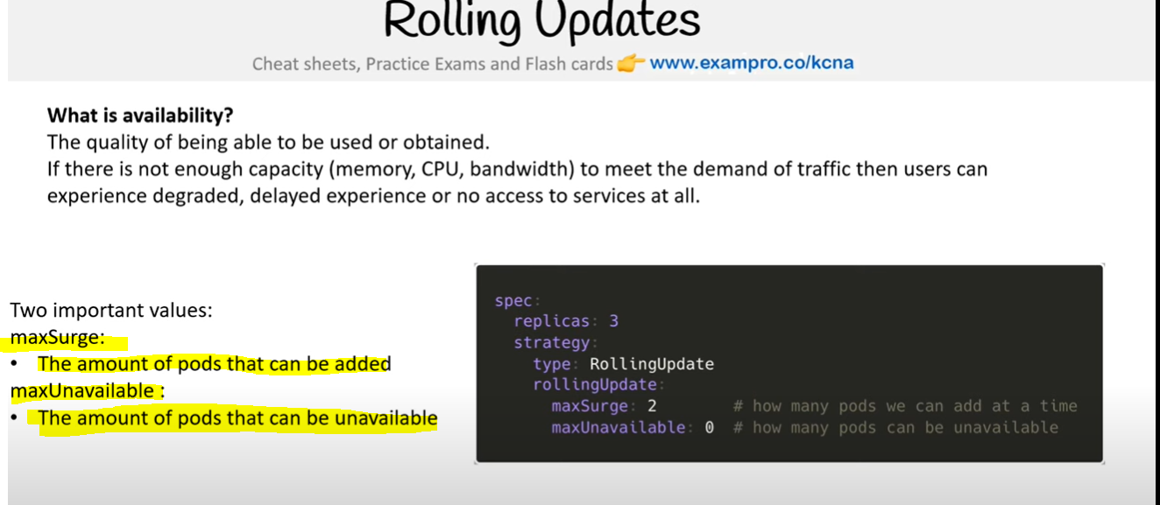

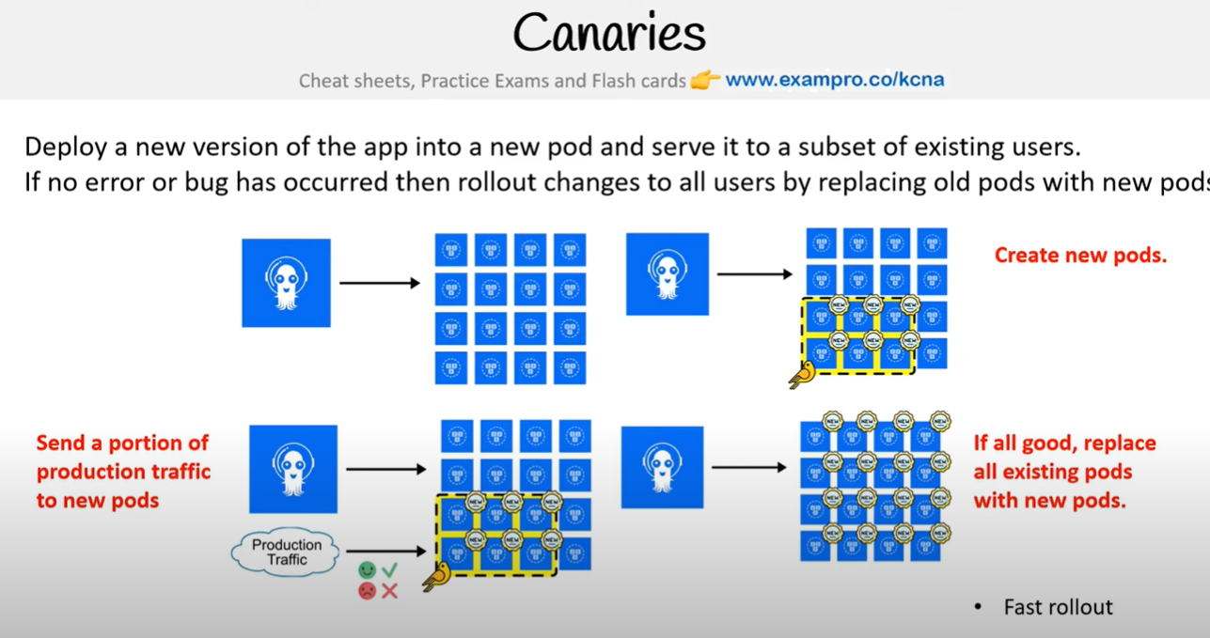

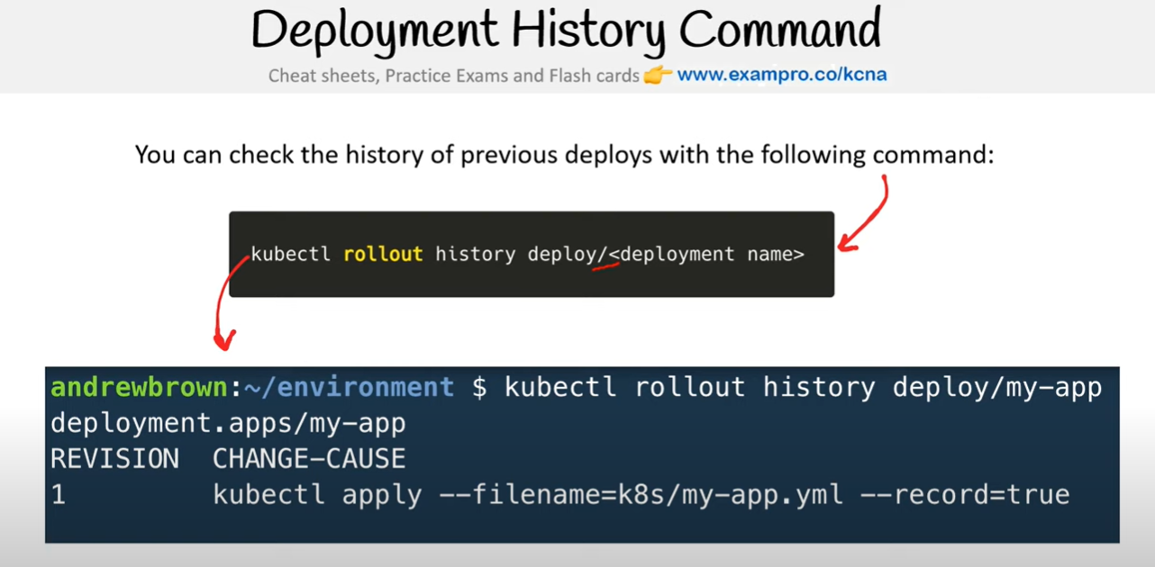

**Kubectl Scale vs AutoScale**

**Scale** in deployment tells how many pods should be always running to ensure proper working of the application. You have to specify it manually. In YAMLs you have to define it in spec.replicas like in example below:

apiVersion: apps/v1

kind: Deployment

metadata:

name: nginx-deployment

labels:

app: nginx

spec:

replicas: 3

selector:

matchLabels:

app: nginx

template:

metadata:

labels:

app: nginx

spec:

containers:

- name: nginx

image: nginx:1.7.9

ports:

- containerPort: 80

Second way to specify scale (replicas) of deployment is use command.

$ kubectl run nginx --image=nginx --replicas=3

deployment.apps/nginx created

$ kubectl get deployment

NAME DESIRED CURRENT UP-TO-DATE AVAILABLE AGE

nginx 3 3 3 3 11s

**Horizontal Pod Autoscaling** (HPA) was invented to scale deployment based on metrics produced by pods. For example, if your application have about 300 HTTP request per minute and each your pod allows to 100 HTTP requests for minute it will be ok. However if you will receive a huge amount of HTTP request ~ 1000, 3 pods will not be enough and 70% of request will fail. When you will use HPA, deployment will autoscale to run 10 pods to handle all requests. After some time, when number of request will drop to 500/minute it will scale down to 5 pods. Later depends on request number it might go up or down depends on your HPA configuration.

Easiest way to apply autoscale is:

$ kubectl autoscale deployment <your-deployment> --<metrics>=value --min=3 --max=10

It means that autoscale will automatically scale based on metrics to maximum 10 pods and later it will downscale minimum to 3. Very good example is shown at [HPA documentation](https://kubernetes.io/docs/tasks/run-application/horizontal-pod-autoscale-walkthrough/#run-expose-php-apache-server) with CPU usage.

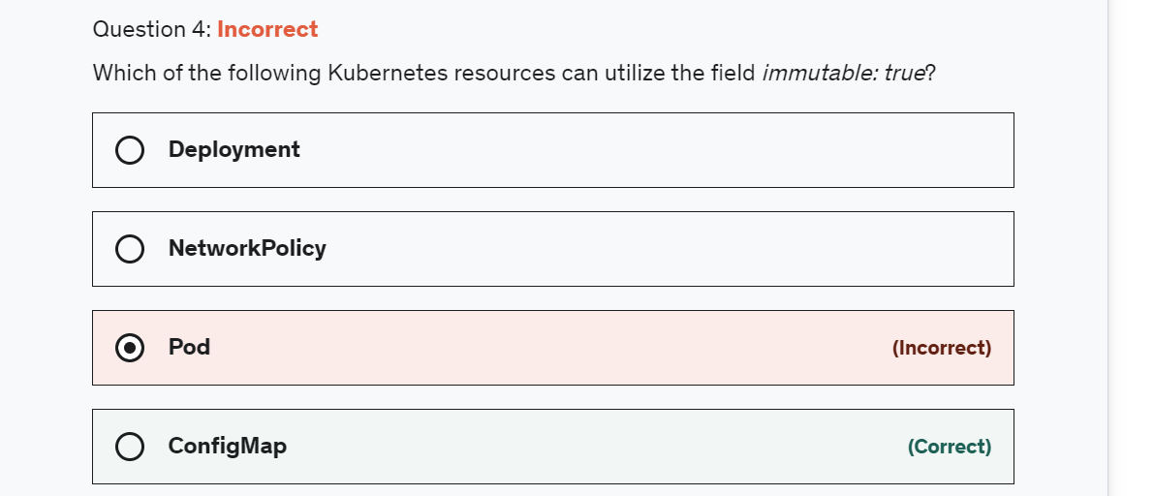

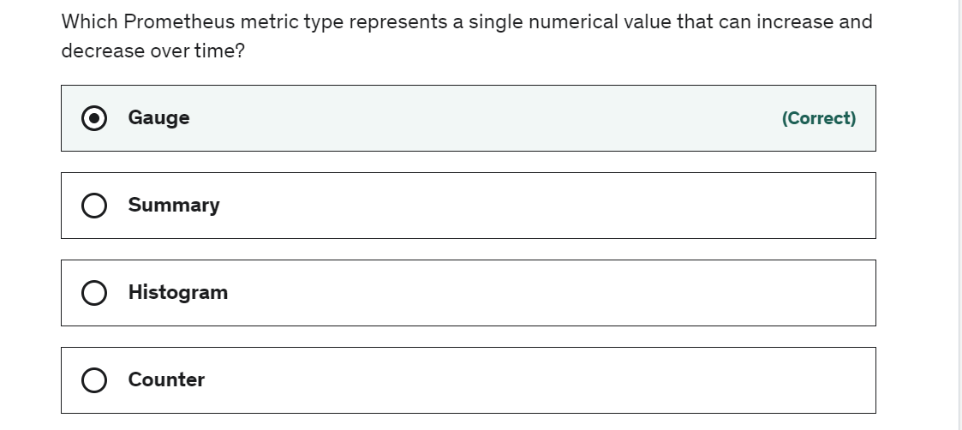

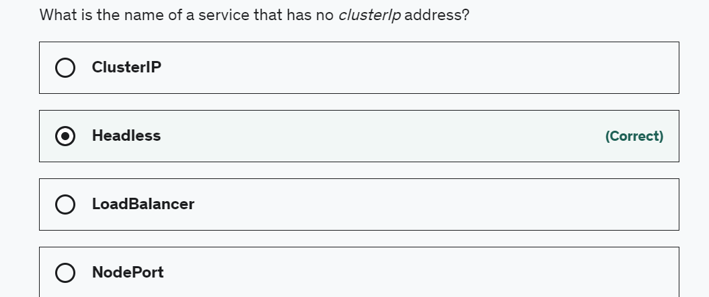

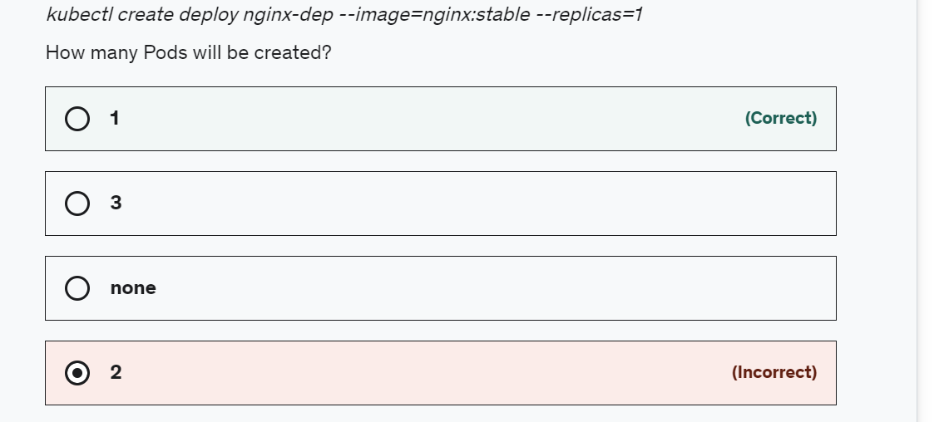

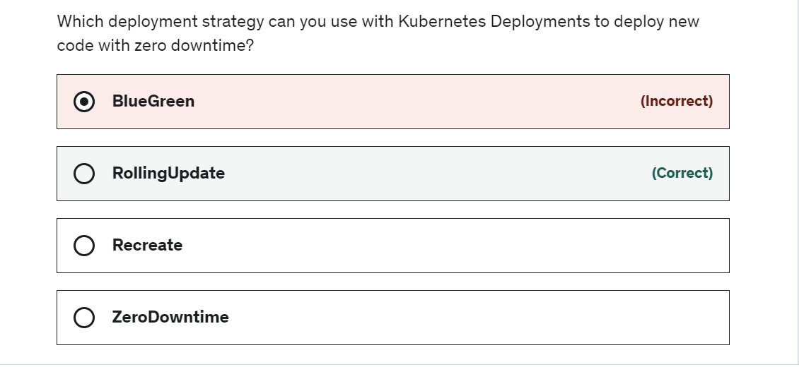

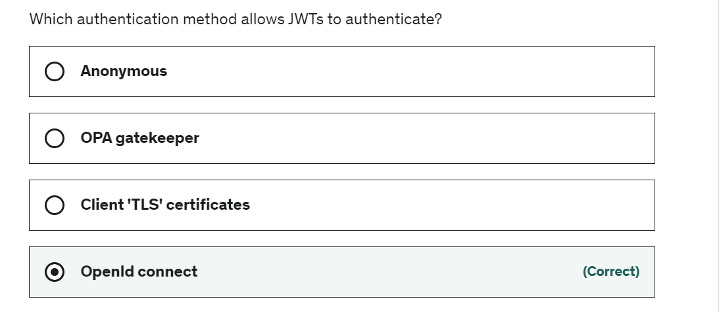

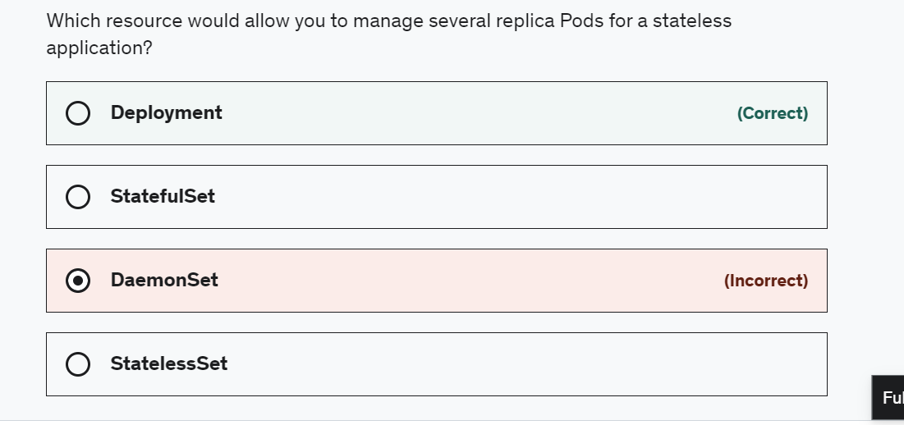

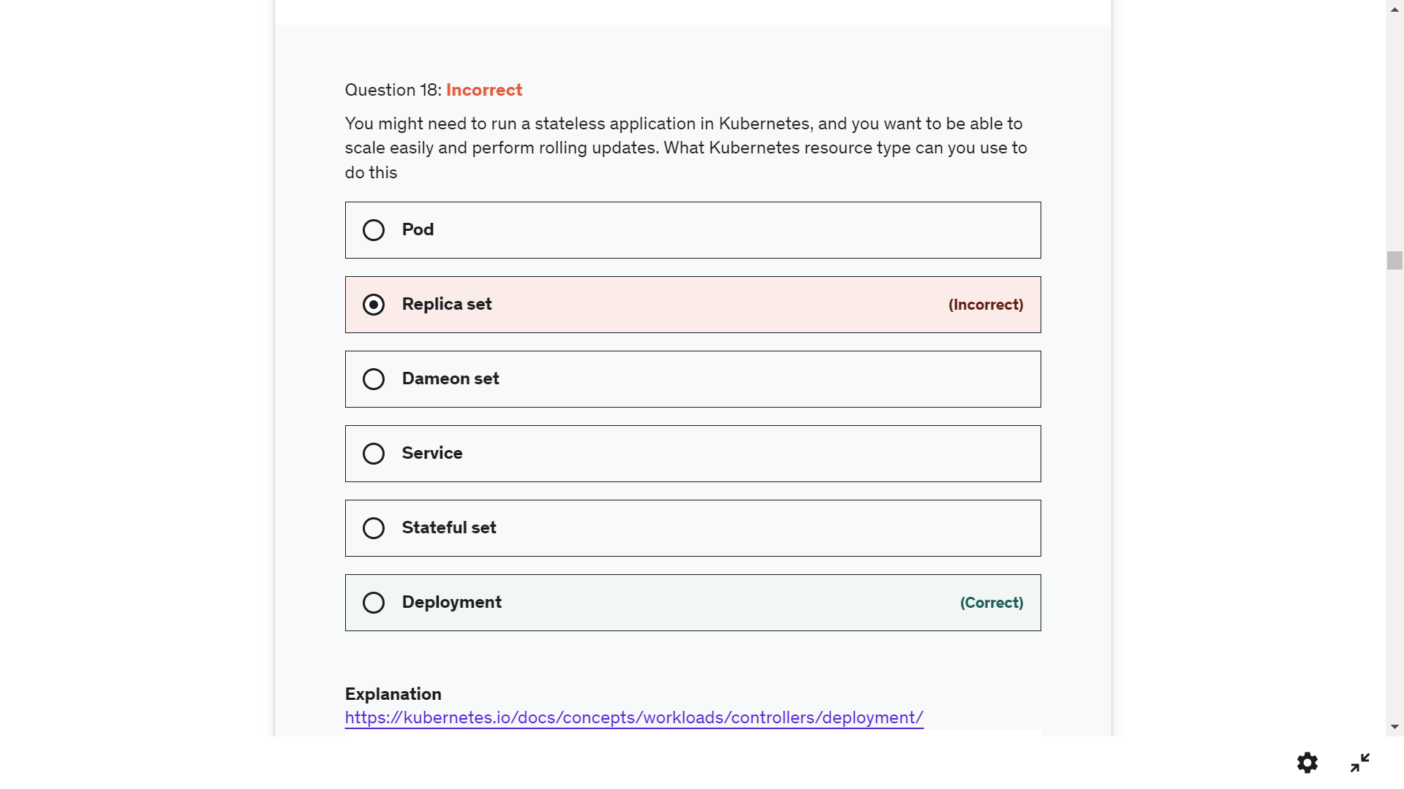

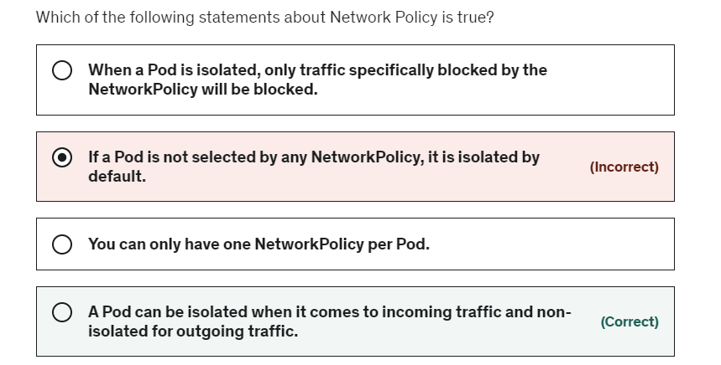

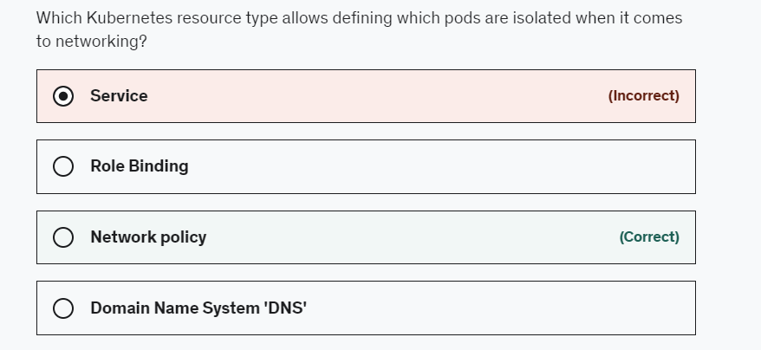

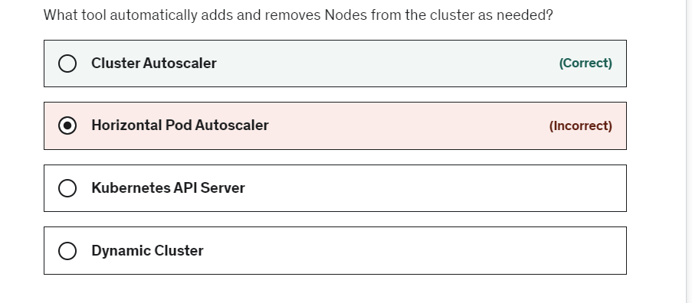

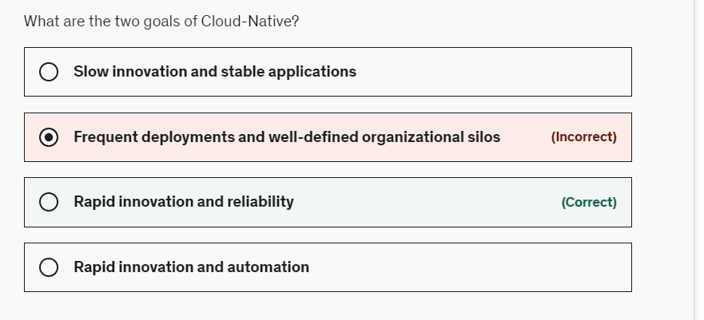

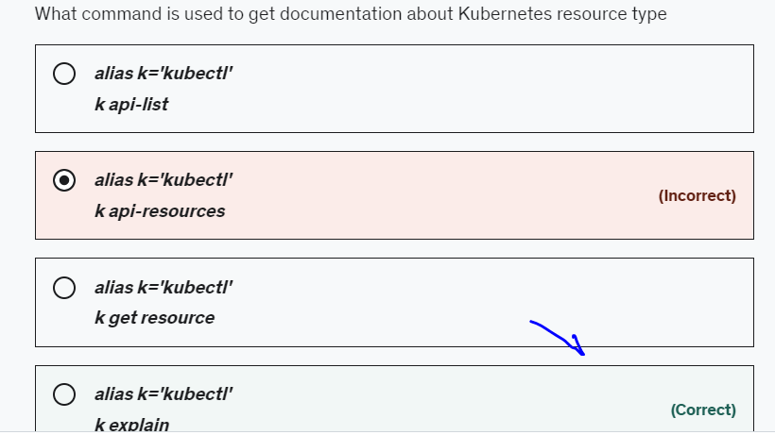

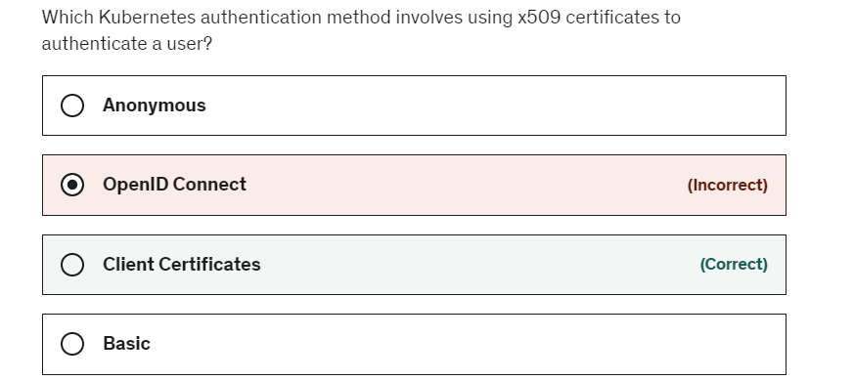

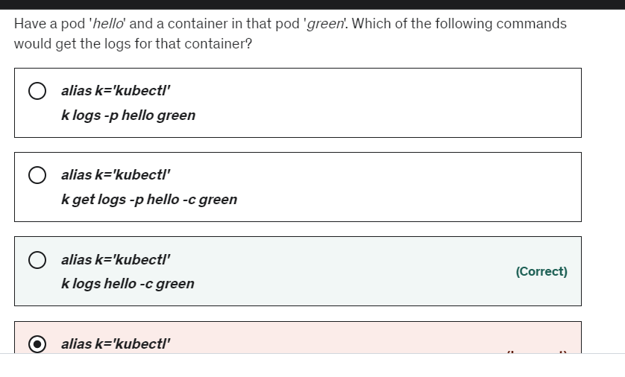

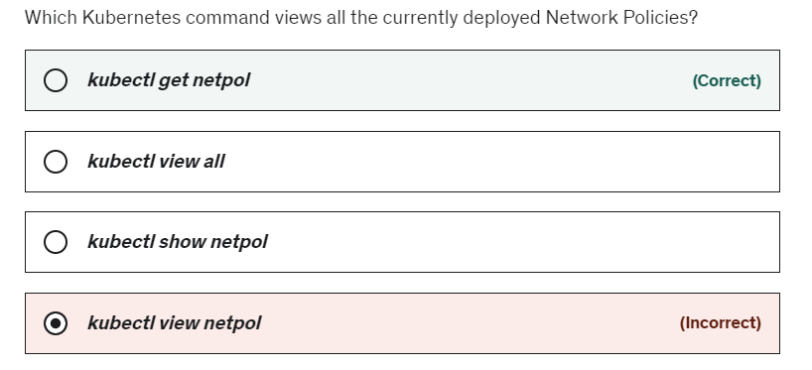

Ways to package deploy and manage kubernetese applications – Helm charts and Kubernetese operators

Scheduling refers to making sure that Pods are matched to Nodes so that the kubelet can run them

A to B deployment is when you want to deploy to only a subset of users.

<https://www.weave.works/blog/kubernetes-deployment-strategies> - read important

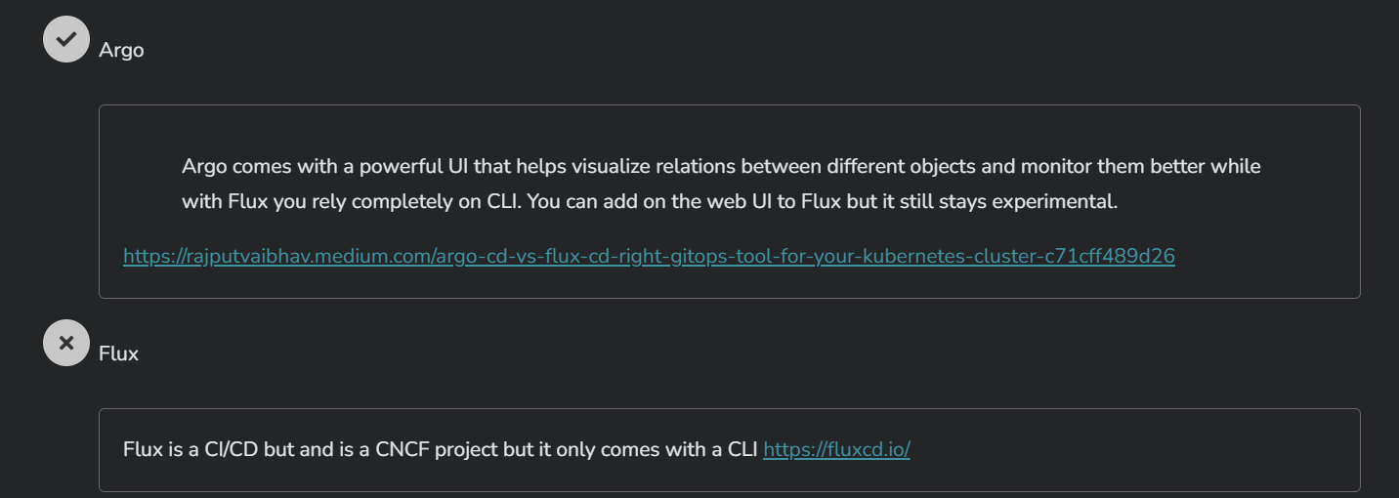

EndpointSlices provide a simple way to track network endpoints within a Kubernetes cluster. They offer a more scalable and extensible alternative to Endpoints.

Fission - fast serverless framework for Kubernetes with a focus on developer productivity and high performance

Many objects in Kubernetes link to each other through owner references. Owner references tell the control plane which objects are dependent on others. Kubernetes uses owner references to give the control plane, and other API clients, the opportunity to clean up related resources before deleting an object. In most cases, Kubernetes manages owner references automatically.

Deployments were designed to replace the legacy ReplicationControllers

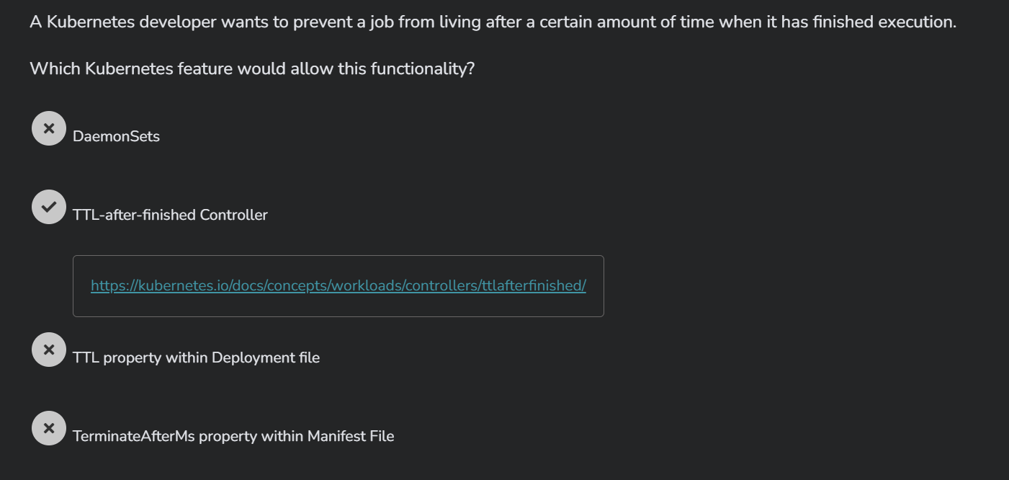

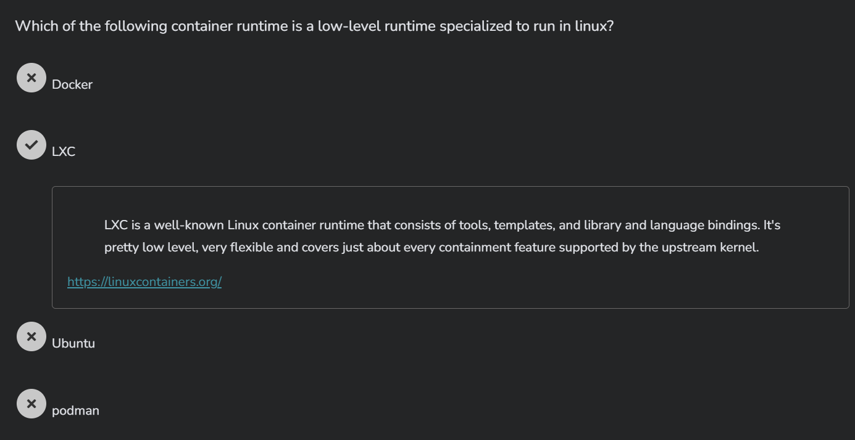

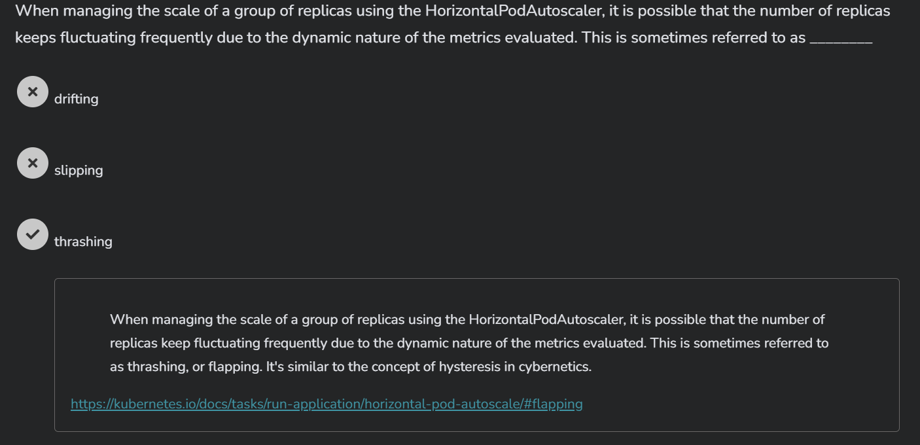

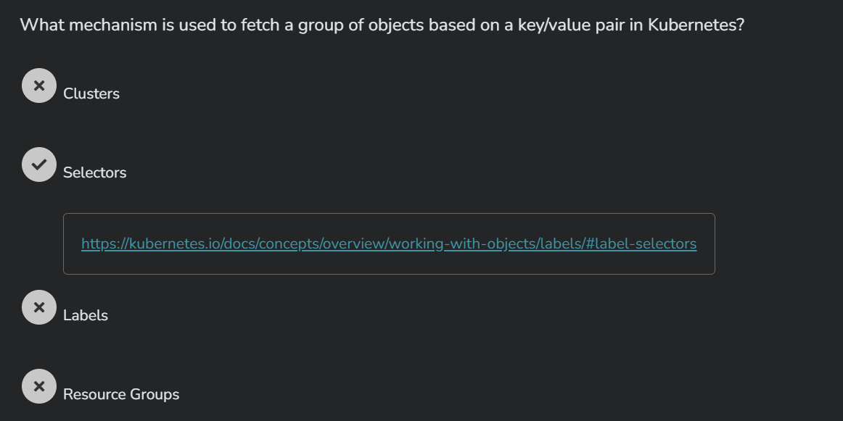

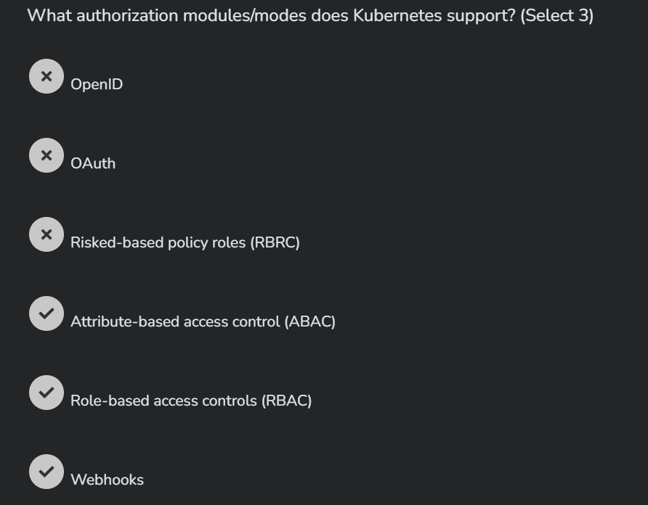

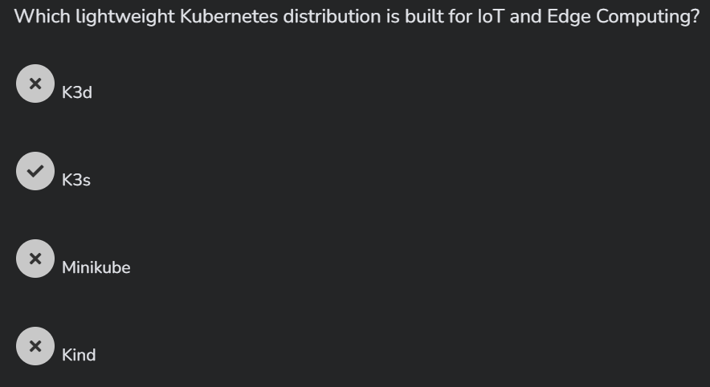

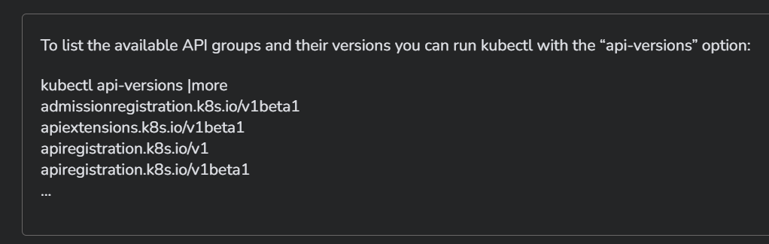

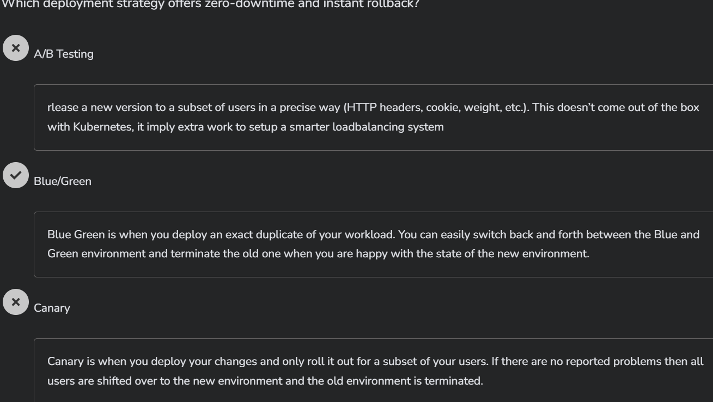

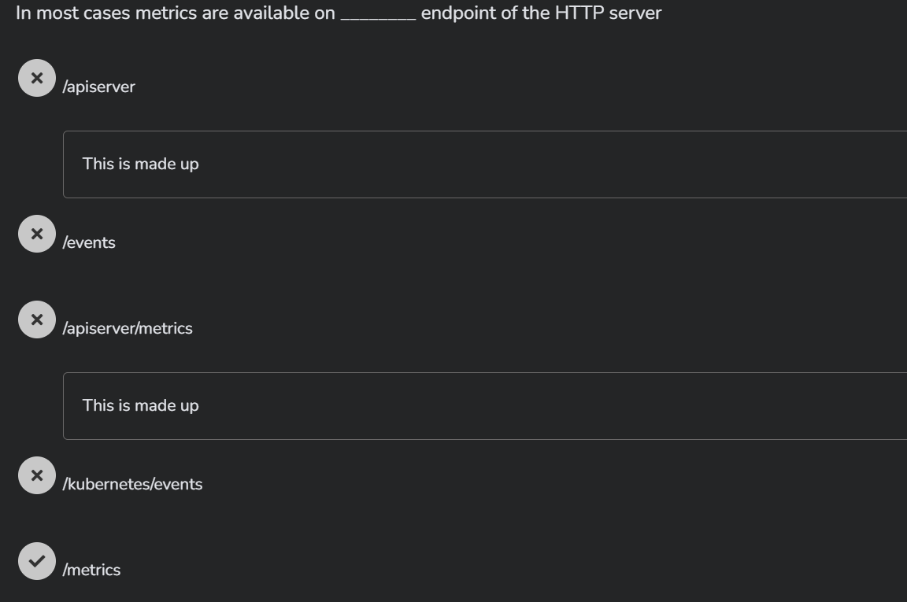

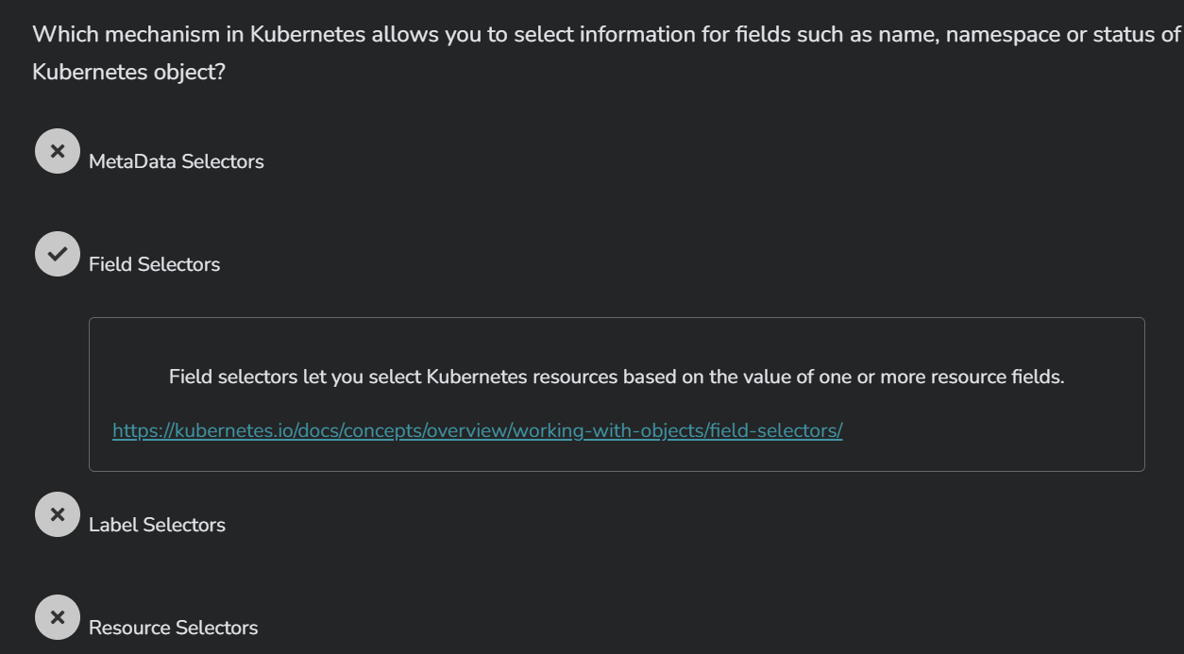

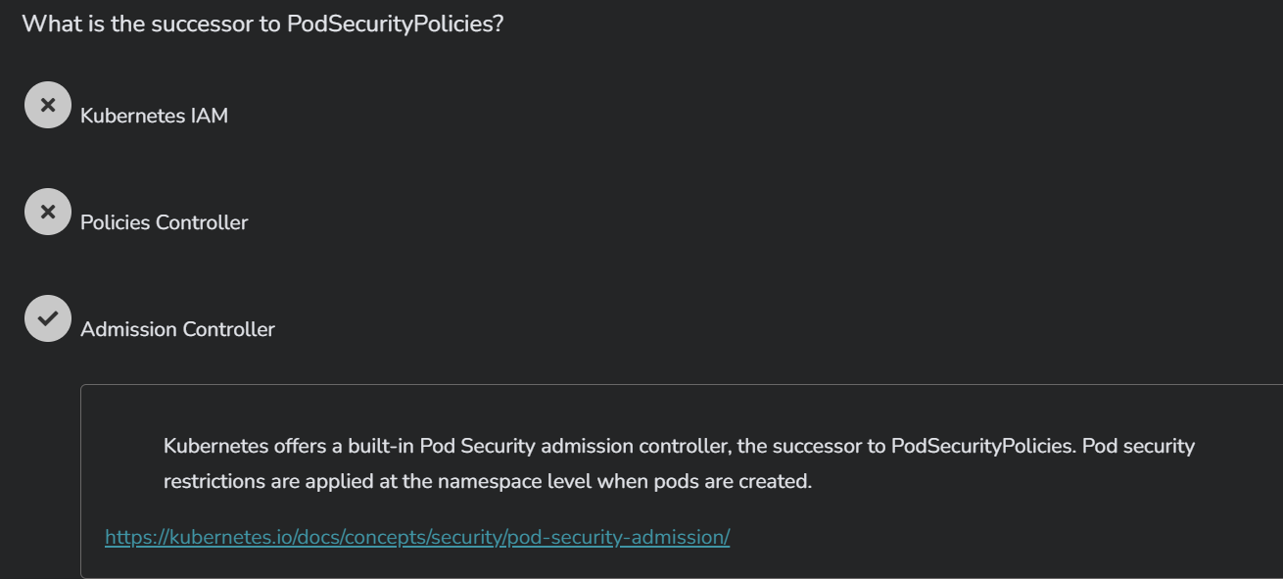

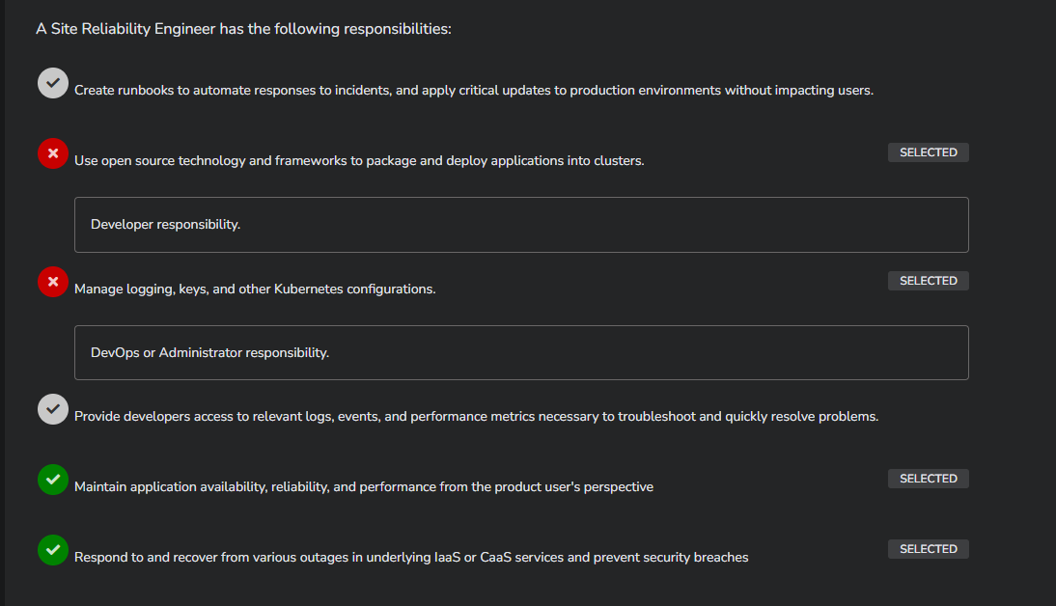

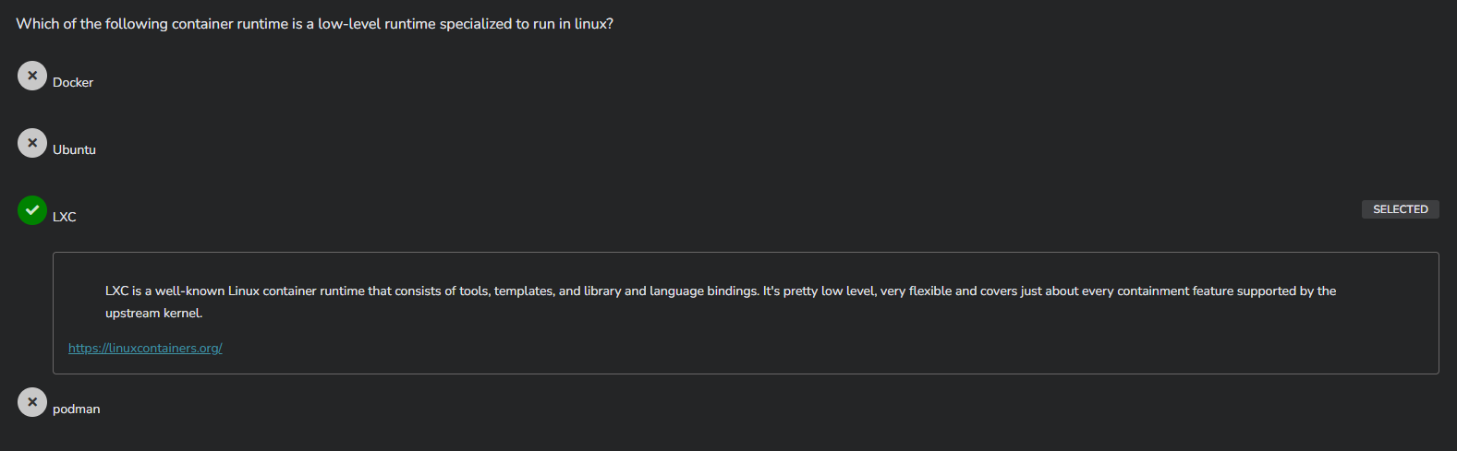

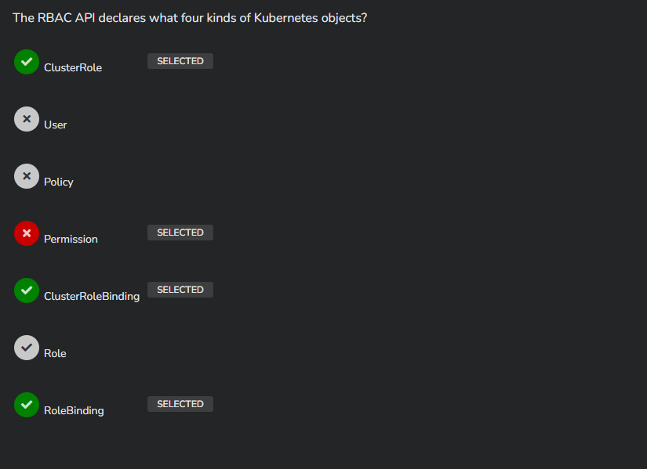

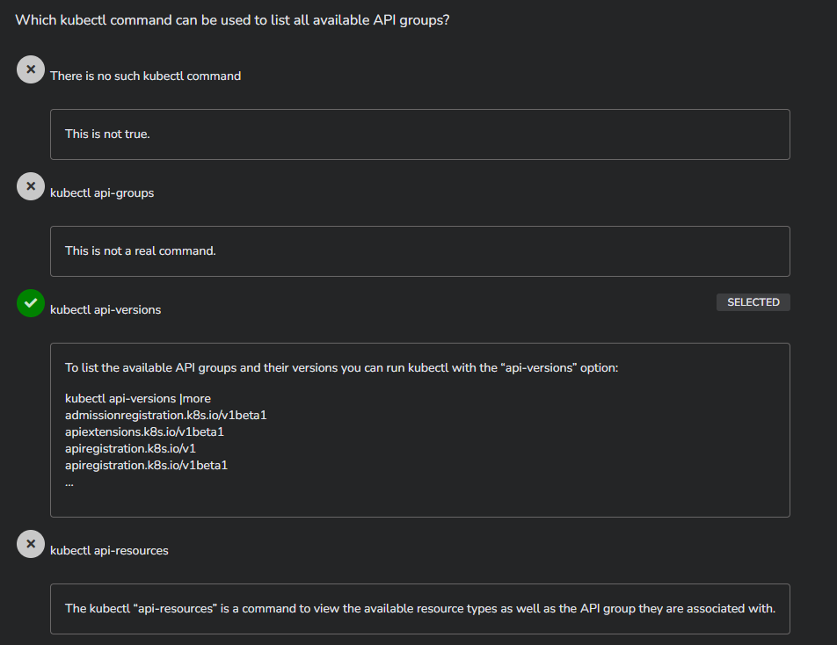

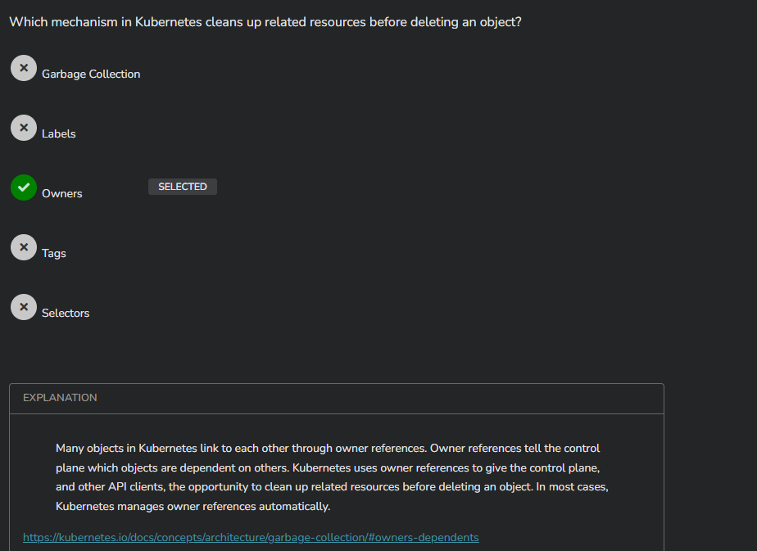

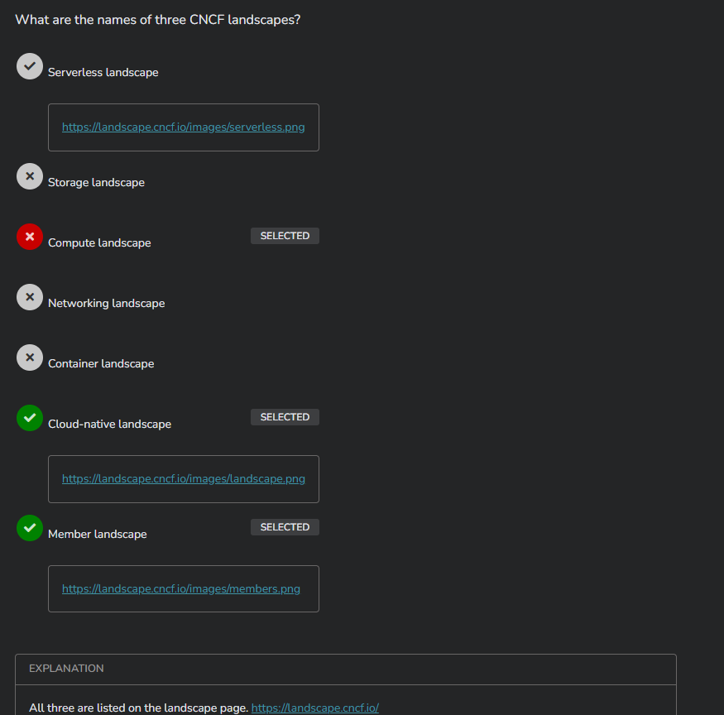

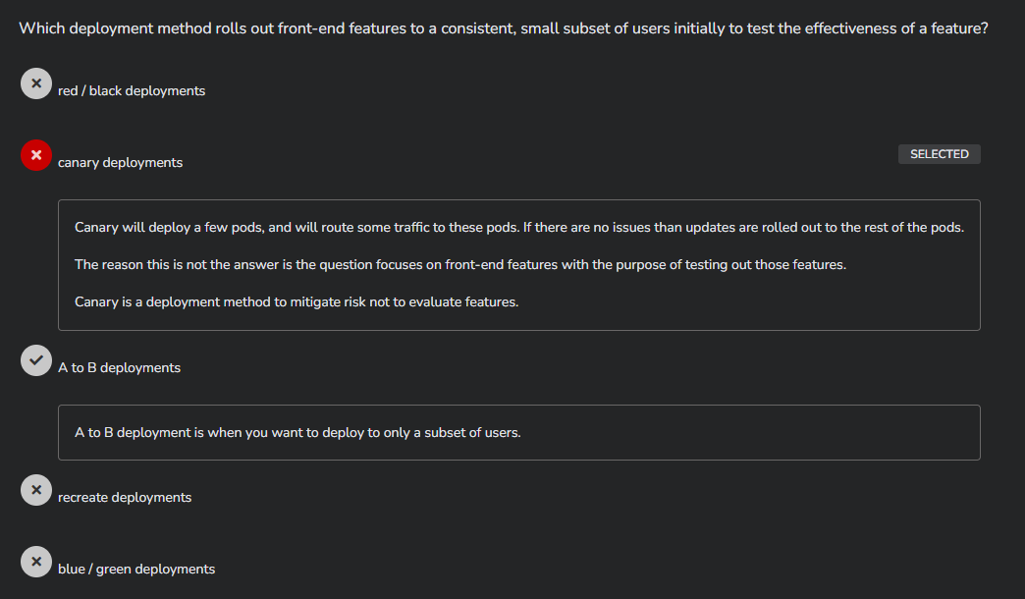

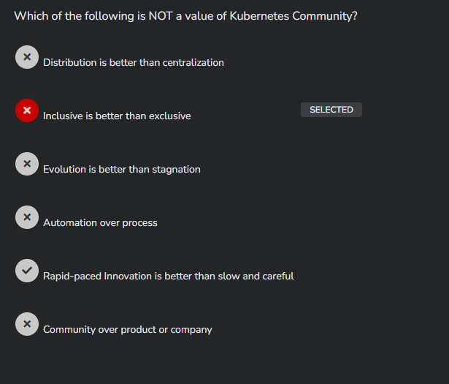

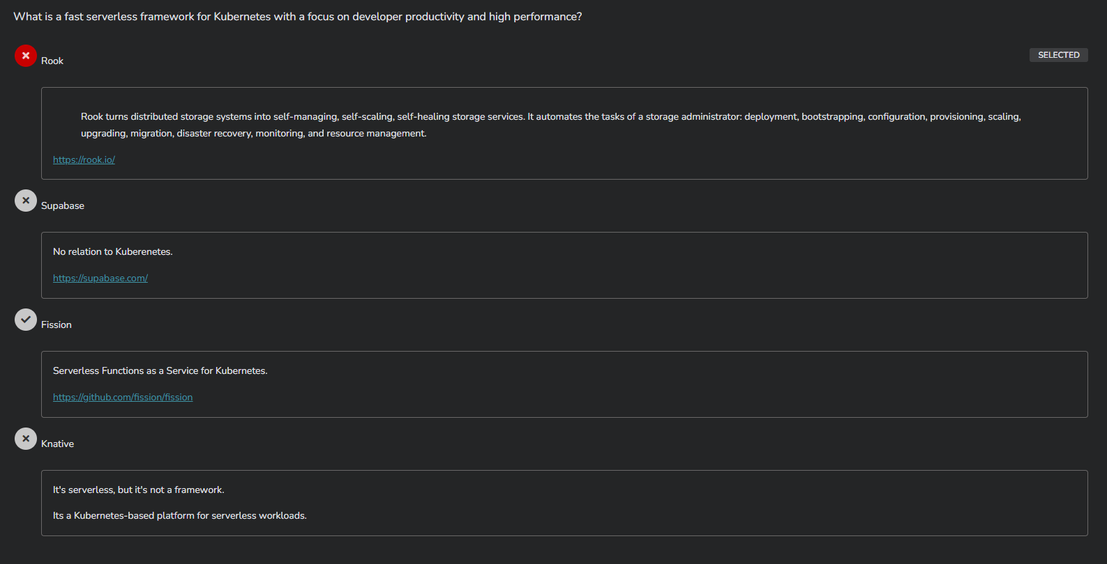

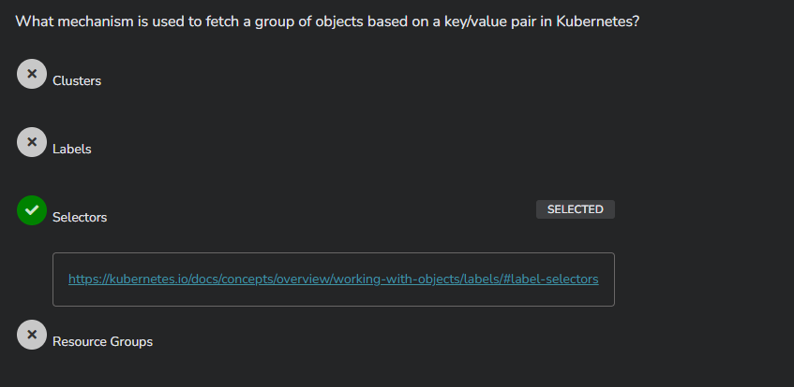

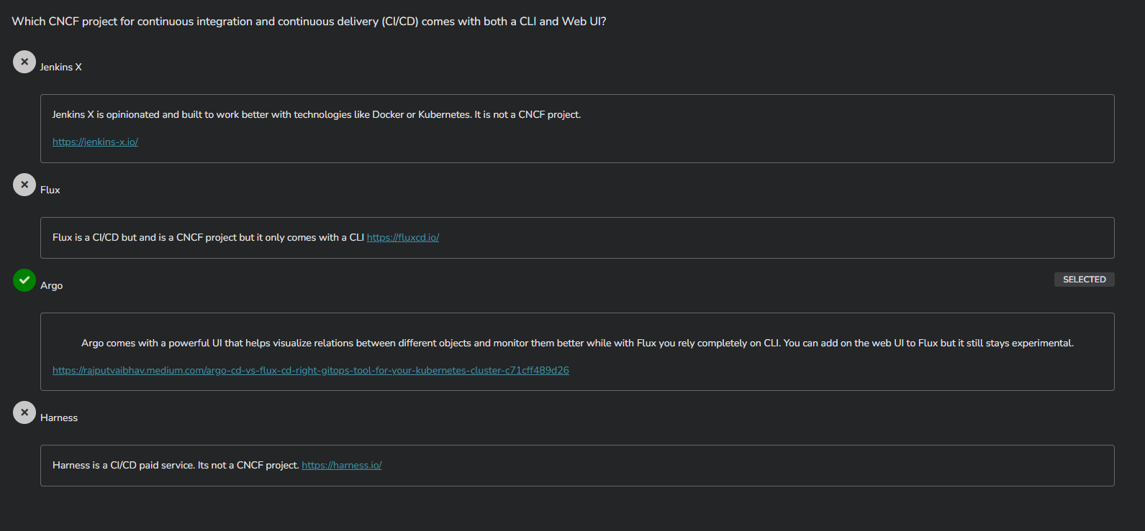

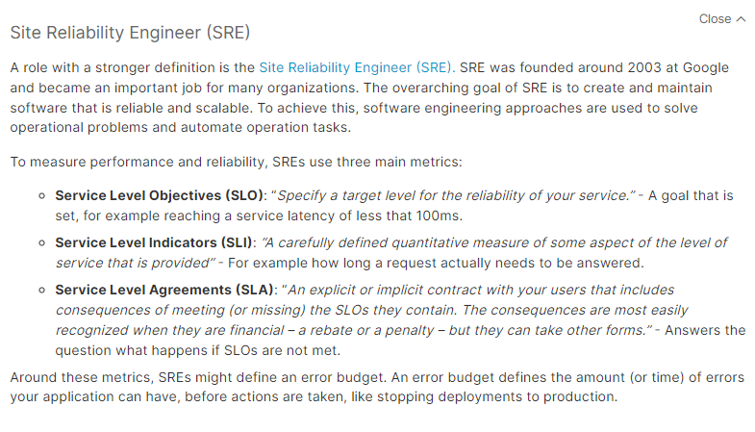

The CNCF has a Technical Oversight Committee (TOC) that is responsible for defining and maintaining the technical vision, approving new projects, accepting feedback from the end-user committee, and defining common practices that should be implemented in CNCF projects.

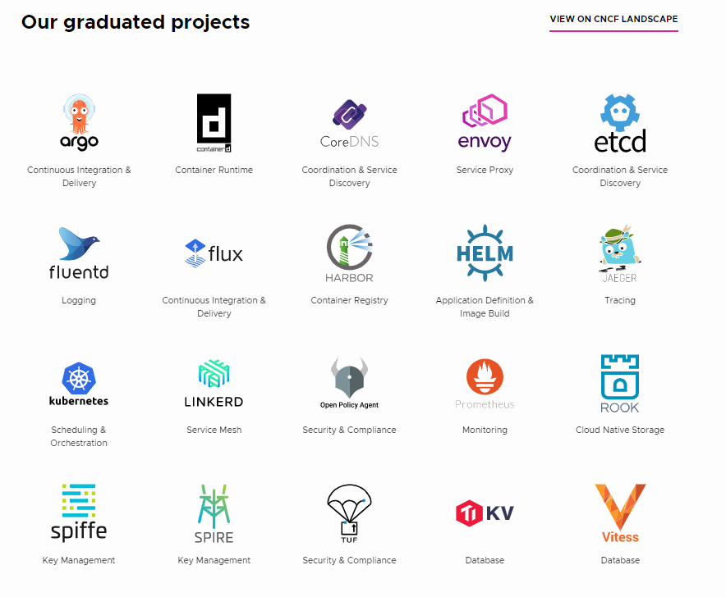

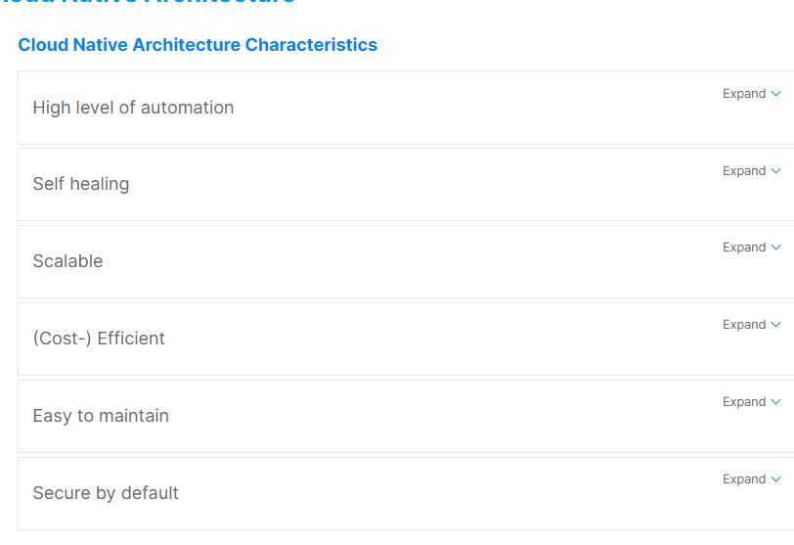

A good baseline and starting point for your cloud native journey is [the twelve-factor app](https://12factor.net/). The twelve factor app is a guideline for developing cloud native applications, which starts with simple things like version control of your codebase, environment-aware configuration and more sophisticated patterns like statelessness and concurrency of your application.

